Warehouse Management Job Aid

Table of Contents

Picking/Staging Parts 2
Issuing Parts 6
Adjusting Inventory 7
Adding/Deleting Inventory 9
Reconcile Inventory 11
Other Reports 13

Picking/Staging Parts
- Sign into Archibus and go to the Warehouse – Parts section of your screen. Select the Parts to be Picked option (highlighted below).
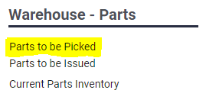
- Check this screen throughout the day to see what parts have been approved for fulfillment. The parts listed are ready to be picked. You can use the PICKED PARTS button to quickly update the quantity of a picked part to the full quantity picked. If you need to partially pick items (not enough available on the shelf) you’ll need to use the EDIT button next to the part and update the quantity manually. You can use the READY FOR PICK-UP button to send an email to the requestor, which informs them their supplies are ready to be issued.
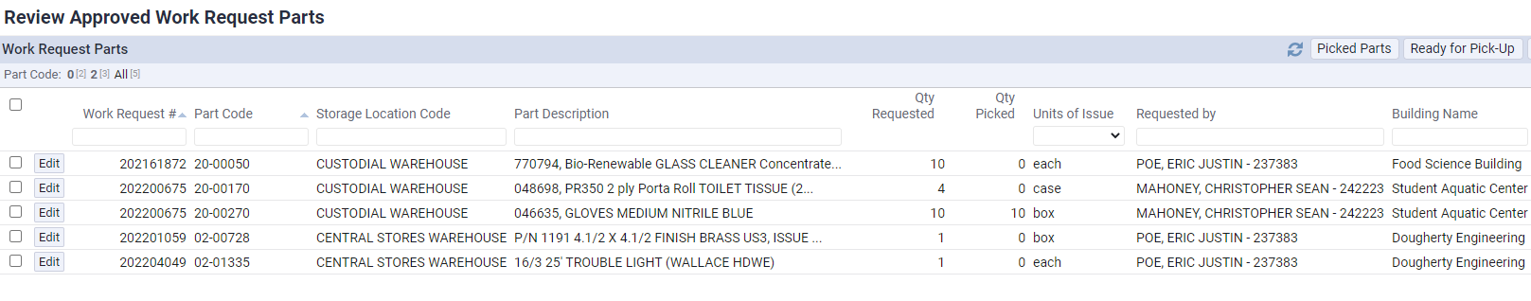

- To fully stage an order, choose the checkbox next to the item you’re picking and then select the Picked Parts button.

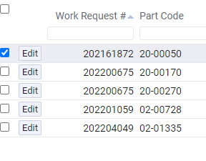

- That will pick all quantities of the item and indicate that they are ready for pickup. Click the OK button and it will take you back to the main screen.
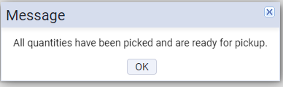

- To partially complete an order, choose the Edit button next to the item you’re picking. That will open a dialogue box that will allow you to indicate the number of parts you’re picking for the request.
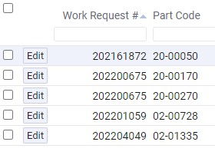

- The Update Work Request Parts Quantity Picked dialogue box opens. Enter the quantity you picked and click Save.
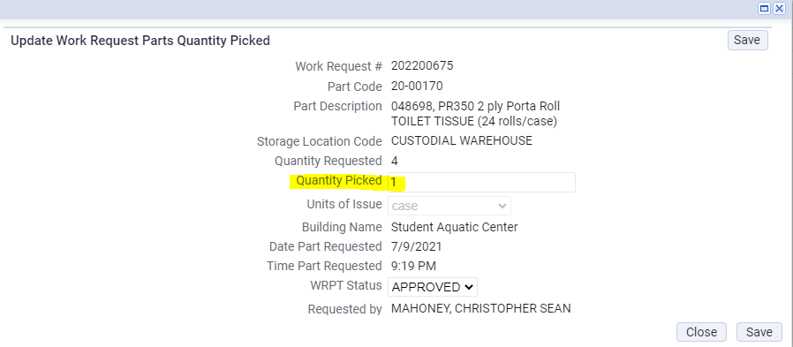

- This will update the item on the Work Request Parts screen, which you can see highlighted below.
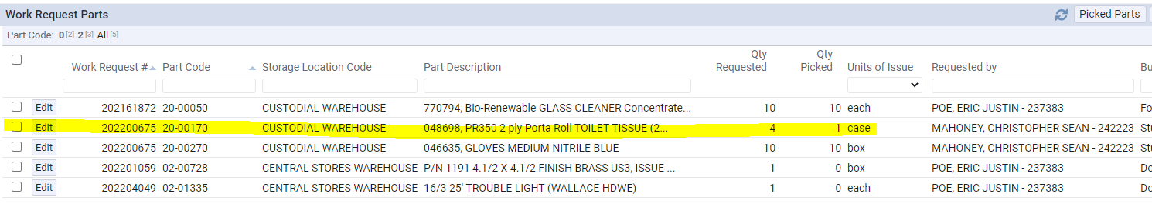
- Once you have all the parts ready for pick-up, choose the checkboxes for the items you have picked then select the Ready for Pick-Up button.
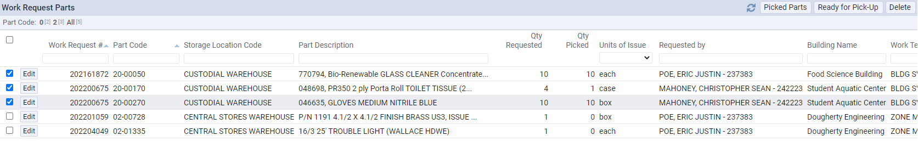

- When you select the Ready for Pick-Up button an email will be sent to the requestor stating that the part(s) are ready for pickup/delivery, and you will be notified of the following:
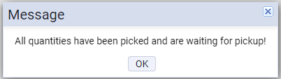

- At this point, you are ready to issue the parts.

Issuing Parts
- When someone comes to collect the parts that have been prepared for pick-up, sign into Archibus and go to the Warehouse – Parts section of your screen. Select the Parts to be Issued option (highlighted below).
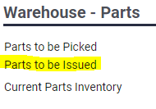
- On the Craftsperson Picking Up Parts screen, you will complete the Parts Issued To field for the name of the person picking up parts. You can use Archibus’ autofill feature to select the person’s name or you can select the ellipsis button to choose the craftsperson picking up the parts.
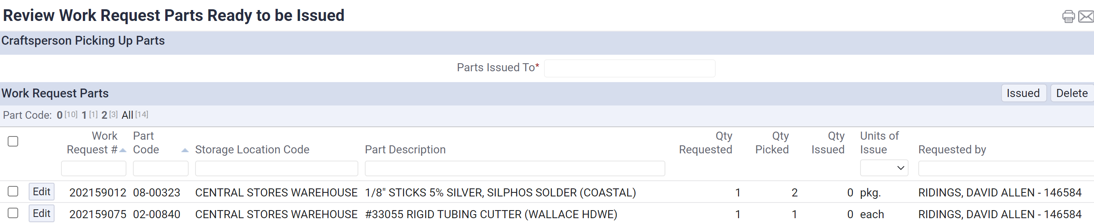

- Locate the part the person is present to collect in your list of parts to be issued. Place a checkmark in the box to the left of the part and click the ISSUED button.
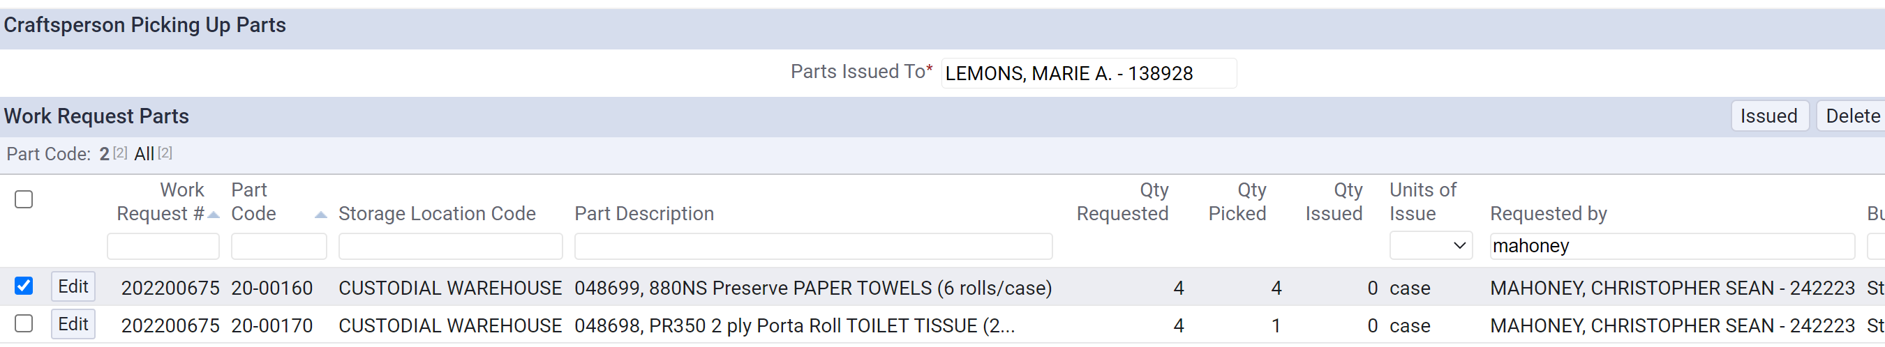

- You will be notified of the following. Once you have clicked the ISSUED button, the quantity will be removed from your inventory.
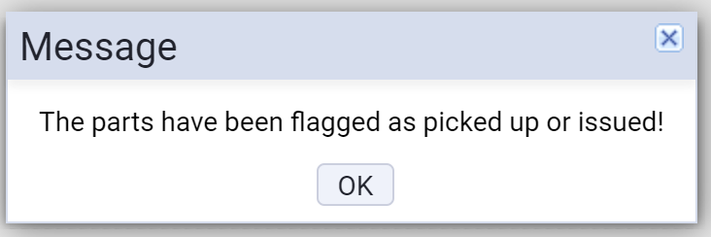

Adjust Inventory

- To adjust your inventory by adding new quantities of existing parts to your inventory, go to the Warehouse – Inv. Mgmt section of your screen. Select the Adjust Inventory option (highlighted below).
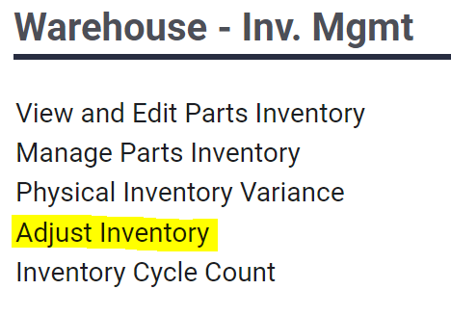

- This will open the Manual Parts Inventory Transaction screen. You will fill in the Part Code and Quantity fields on the screen to indicate the new quantities of each item you have received in your inventory.
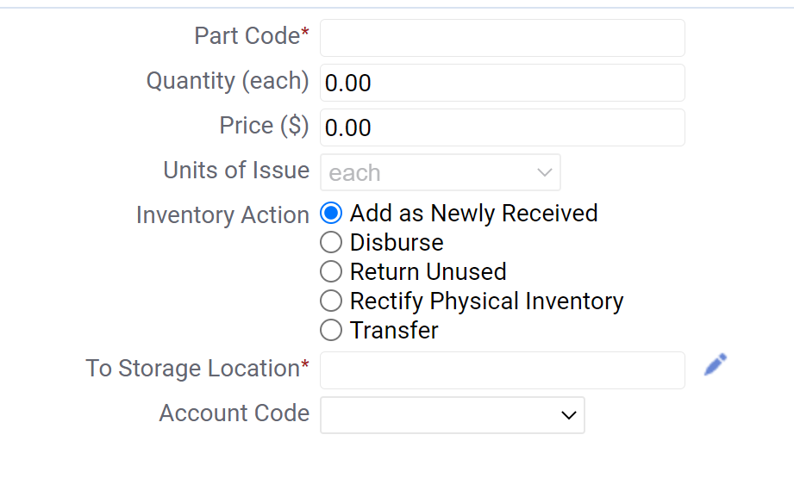
- If you know the part code, you can just manually enter that in the Part Code field. If you do not know the part code, you can click on the ellipsis and search for the item by keying in the product description. Select the item that matches your received inventory product. This will fill in the part code on the Manual Parts Inventory Transaction screen.
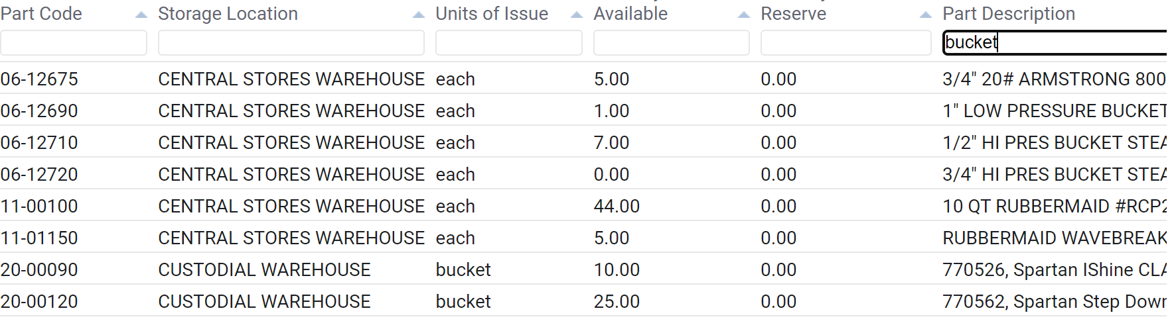

- Enter the quantity of the part you have received and select the Inventory Action ADD AS NEWLY RECEIVED. The TO STORAGAE LOCATION field is required (as indicated by the red asterisk). Select the ellipsis to choose which warehouse location you’re using, then click the SAVE button. You will receive a note on the screen that indicates the inventory was saved successfully. To leave the Manual Parts Inventory Transaction screen, you will need to click on the Warehouse Manager Home button to go back to the main page of Archibus.
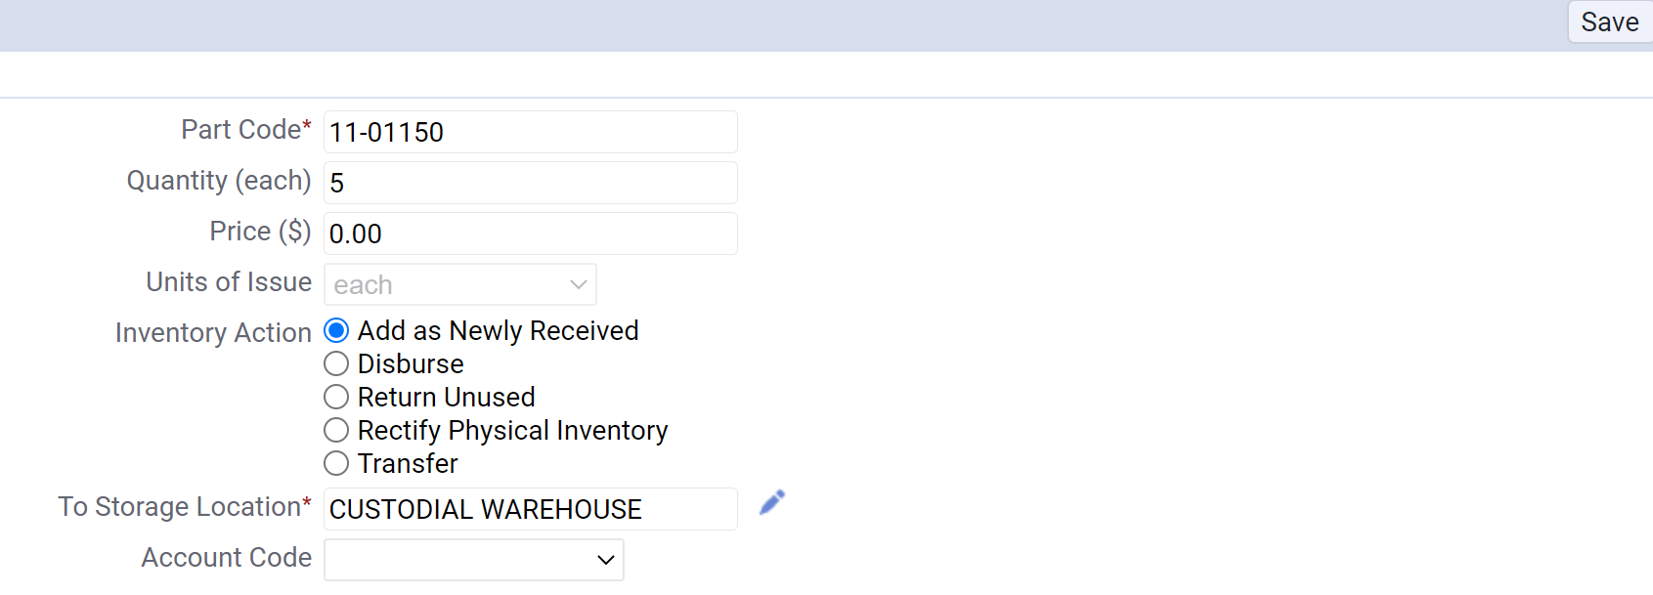

- In the event someone returns inventory to be added back to the warehouse because they did use/need the part, you will do the same process as above, except your INVENTORY ACTION will be RETURN UNUSED. Click the SAVE button. This process adds the unused/returned item back into your inventory.
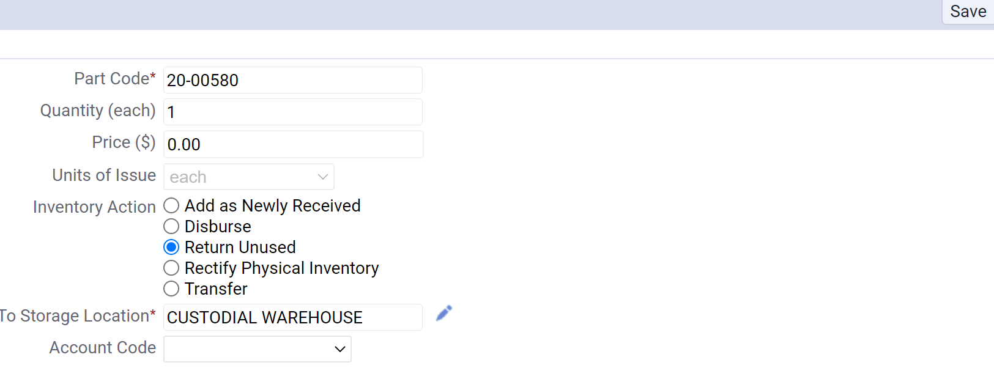

- Again, if adjustments need to be made to your inventory because something was broken or stolen, you will also use this screen. In this event, your INVENTORY ACTION will be RECTIFY PHYSICAL INVENTORY. This inventory action type will remove the Account Code field from the screen. Click the SAVE button and your inventory will be adjusted.
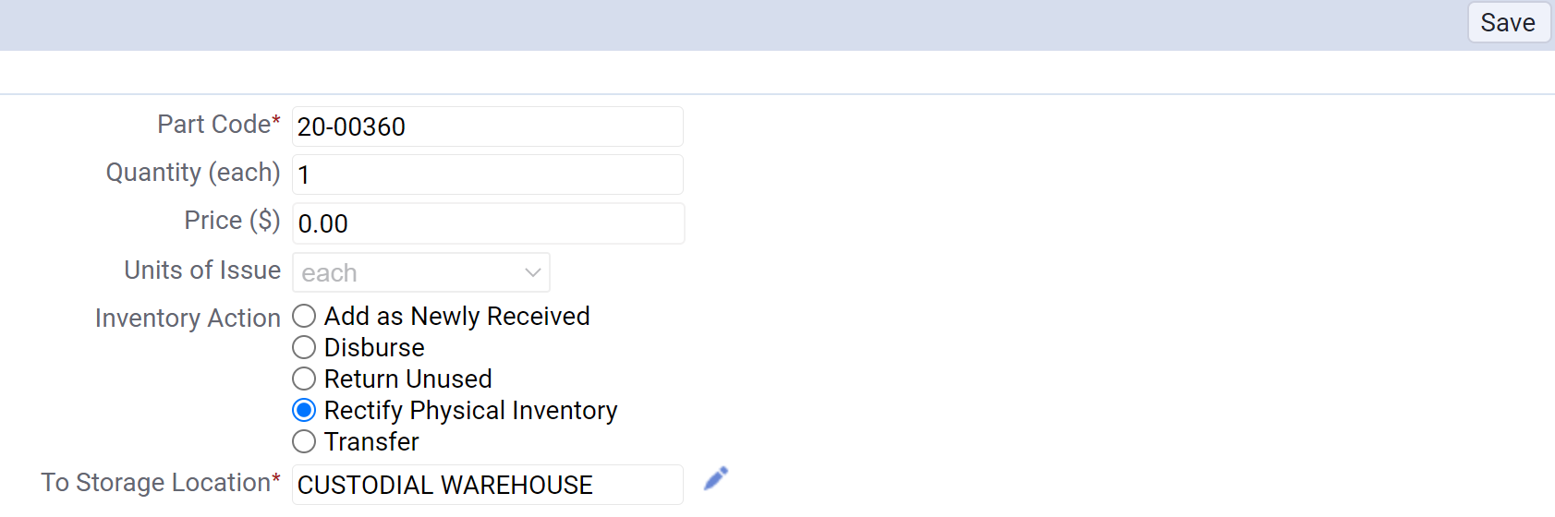

Adding/Deleting Inventory

- To adjust your inventory by adding new quantities of new parts to your inventory, go to the Warehouse – Inv. Mgmt section of your screen. Select the View and Edit Parts Inventory option (highlighted below).
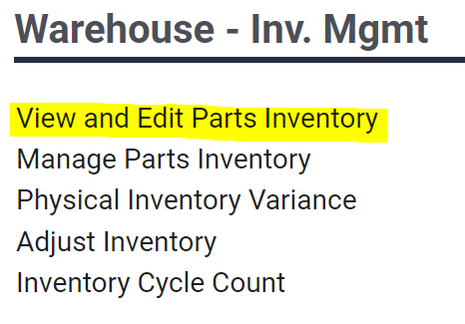

- To add new parts to your inventory, click the plus sign button on the Define Parts page.
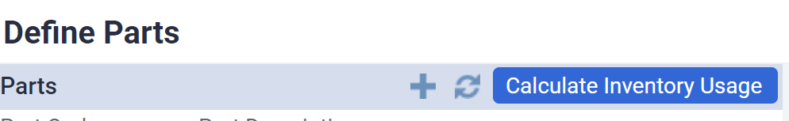

- The fields to complete to add a new part to your inventory are located on this page. See step 4 for a description of each field.
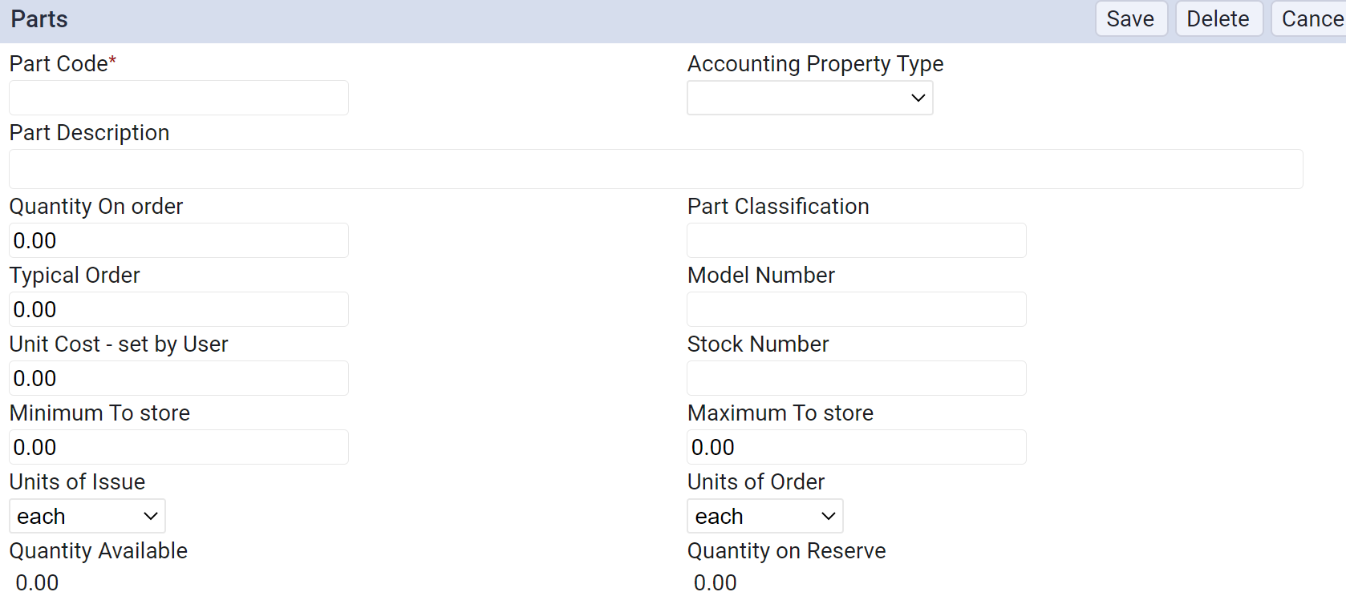

- Parts field descriptions:
  - PART CODE – For Building Services, part codes start with a 20- and need to be unique.
  - ACCOUNTING PROPERTY TYPE – Classifies warehouse items for accounting purposes (Building Services would probably only use BLDG SVCS types).
  - PART DESCRIPTION – Brief description of the part.
  - QUANTITY ON ORDER – Quantity being ordered.
  - PART CLASSIFICATION – Used to group similar type parts together. Use the ellipsis to choose the classification.
  - TYPICAL ORDER – Quantity that is usually ordered on a typical order.
  - MODEL NUMBER – The model number of the part from the vendor.
  - UNIT COST – The initial setup cost of the part
  - STOCK NUMBER – A field for the Legacy system – not necessary to use when adding new parts.
  - MINIMUM TO STORE – The lowest amount stock should drop to before prompting a re-order to replenish stock.
  - MAXIMUM TO STORE – The highest amount of stock that you want to store on the shelves. Used when calculating how many are needed in order to get items back above the minimum.
  - UNITS OF ISSUE – The number of units used when issuing parts (may be different from what is actually purchased).
  - UNITS OF ORDER – The number of units when purchasing parts (may be different from what is issued out to users).
  - QUANTITY AVAILABLE – The quantity of the part on the shelf or the quantity reserved.
  - QUANTITY ON RESERVE – The quantity that user has requested. It can be on the shelf or in the staging areas, but it cannot be requested by another user.

- Once the Parts form is filled out, click the SAVE button. This will add the part to your inventory.
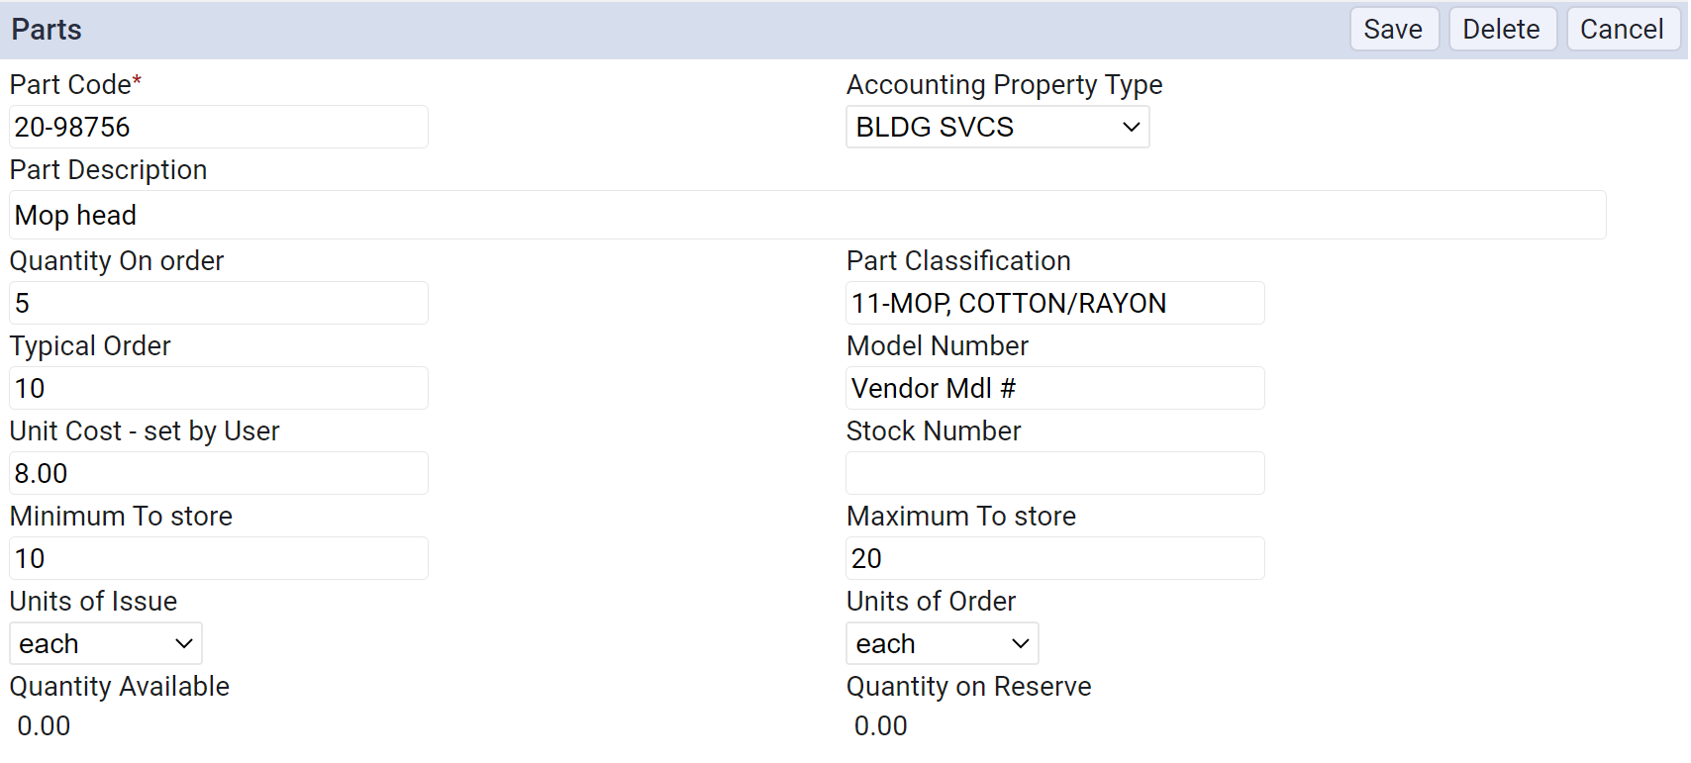

- To delete inventory, you will need to email Shawn Benson or Kevin Garland to have them remove the item for you.

Reconcile Inventory
- You should reconcile your inventory daily. To do this, go to the Warehouse – Reports section of your screen. Select the Parts Transactions option (highlighted below).
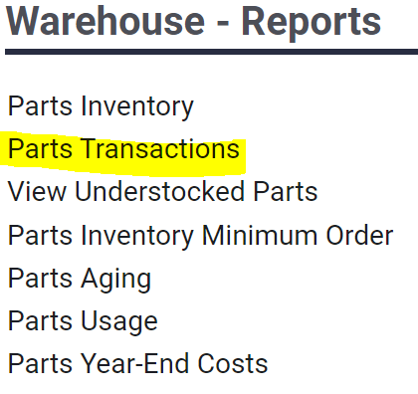

- The View Inventory Transactions screen will allow you to review all the transactions that occurred during the day. To print a report for your warehouse, select the REPORT button.

- Choose your warehouse from the drop-down menu on the Parameter screen and click the OK button. The report for your daily transactions will generate.
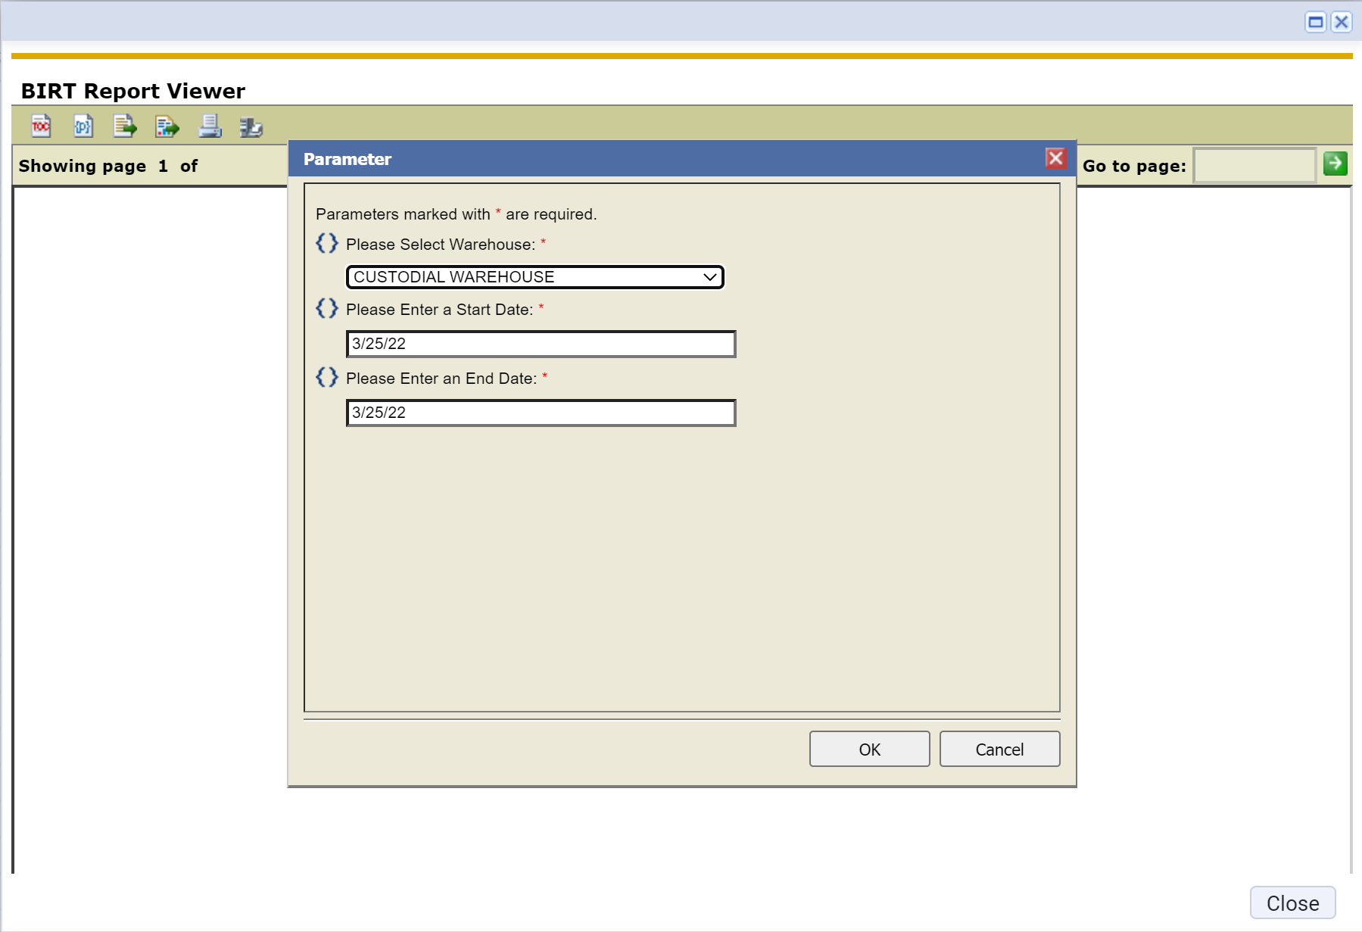

- Once your report generates, click the print button to print the report. You will use this report to verify the quantities on these specific inventory items to verify your inventory is accurate. If there is a discrepancy, you will need to go to the ADJUST INVENTORY screen to correct your inventory quantities (See Adjusting Inventory section for process). Additionally, if there are any discrepancies on the report, you will need to highlight them, sign and date the report, then file for auditing.
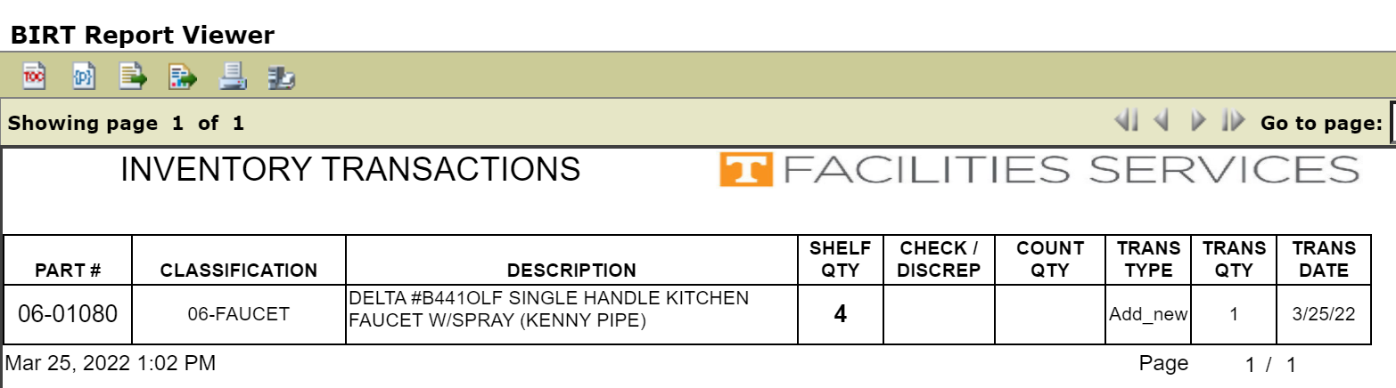

Other Reports
Other reports that you can use are outlined below.
Parts Inventory Minimum Order
- You can use the PARTS INVENTORY MINIMUM ORDER Report to show you all the parts that have dropped to or below the minimum.
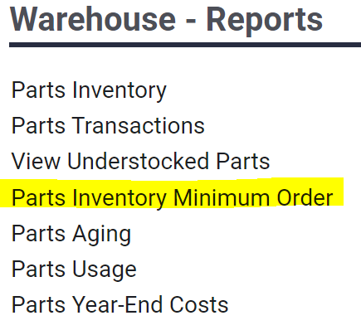
- When you open the report, scroll to the far right side of the page to view the NEED TO ORDER column. These numbers show how many of each inventory item you need to order to bring you back up to the MINIMUM TO STORE quantity.
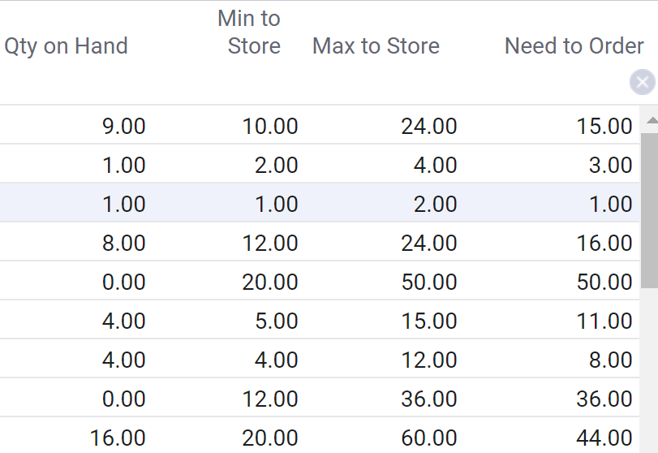

Parts Aging Report
- You can use the PARTS AGING Report to show you parts that haven’t been used in a long time. This can help you decide if you should get rid of these parts to free up warehouse space or not.
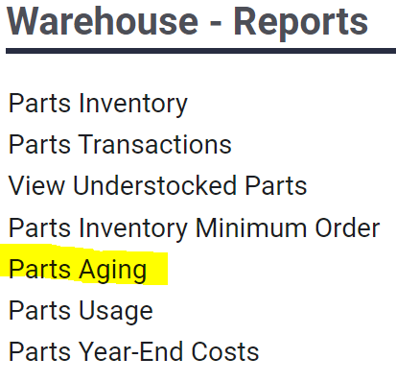
Parts Inventory Report
- The PARTS INVENTORY screen allows you to print a complete inventory report for use when you’re doing a full inventory count at the end of the fiscal year to double check that everything has a proper quantity in the system.
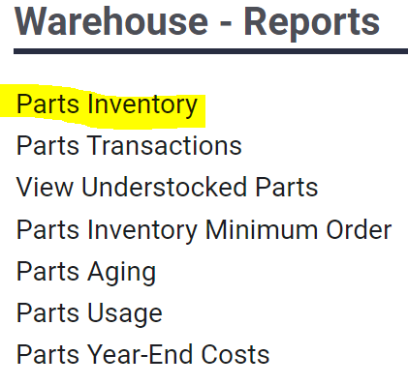

Parts Year-End Costs Report
- The PARTS YEAR-END COSTS Report creates a dollar amount for the current inventory. This is generated at year-end for auditing purposes.
