|  |
| --- |
| **Office of Information Technology Communications Group** |

**Structured Cabling Design & Installation Requirements**

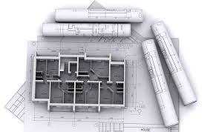

*Guidelines for Facilities Design, Construction Architects, Design Engineers and Building System Integrators to design physical pathways for datacom and telecom infrastructure for new constructions and building renovation projects across the University of Tennessee Knoxville campus.*

Last Revised

**January 20, 2023**

**Table of Contents**

|  |  |  |
| --- | --- | --- |
| **Section** | **Topic** | **Page** |
| 1.0 | Introduction ............................................................................................................. | 3 |
|  |  |  |
| 2.0 | Contractor Requirements ........................................................................................ | 4 |
|  |  |  |
| 3.0 | Cabling Certification Requirements ......................................................................... | 5 |
|  |  |  |
| 4.0 | Project Communication Workflow .......................................................................... | 6 |
|  |  |  |
| 5.0 | Architectural Drawings Requirements ..................................................................... | 8 |
|  |  |  |
| 6.0 | Variances................................................................................................................. | 10 |
|  |  |  |
| 7.0 | MDF/IDF Room Usage and Restrictions Requirements ........................................... | 11 |
|  |  |  |
| 8.0 | MDF/IDF Design Requirements …………………………………………………………………………… | 12 |
|  |  |  |
| 9.0 | MDF/IDF Rack Layout Requirements ....................................................................... | 20 |
|  |  |  |
| 10.0 | Outside Plant (OSP) Pathway Requirements ........................................................... | 26 |
|  |  |  |
| 11.0 | Inside Plant (ISP) Cabling Infrastructure Requirements........................................... | 29 |
|  |  |  |
| 12.0 | Inside Plant (ISP) Cabling Pathway Requirements ………………………......................... | 36 |
|  |  |  |
| 13.0 | Work Area Outlets Requirements ............................................................................ | 40 |
|  |  |  |
| 14.0 | Labeling Requirements ............................................................................................ | 45 |
|  |  |  |
| 15.0 | Device Naming……..……………………………………………………………………………………………... | 47 |
|  |  |  |
| **Appendices** | |  |
|  | Appendix A – Vendor Installation Compliance Sign-off …………………….…………………. | 50 |
|  | Appendix B – 2-Post Premise Wiring Enclosures ………………………………………….……… | 52 |
|  | Appendix C – Wall Mount Premise Wiring Enclosures ………………………………………... | 53 |
|  | Appendix D – Harsh Environment Wall Mount Premise Wiring Enclosures ……….... | 54 |
|  | Appendix E – Quad Cab Wall Mount Premise Wiring Enclosures ……………………….… | 55 |
|  | Appendix F – Full Size Premise Wiring Equipment Enclosures ……………………..……… | 56 |
|  | Appendix G – Cabling Parts List ….……………………………………………………….………………. | 57 |
|  | Appendix H – Connectors Parts List ….…………………………………………………………………. | 58 |
|  | Appendix I – Cross-Connects Parts List ………………………………………….……………………. | 59 |
|  | Appendix J – Cable Management Parts List ………………………………….……………………… | 60 |
|  | Appendix K – Miscellaneous Materials and Parts List ……………………………………….… | 62 |
|  | Appendix L – OIT Standard Requirements Variance Form …………………………………… | 64 |
|  | Appendix M – Sample Labeling ……………………………………..…….………..………………….… | 65 |
|  | Appendix N – OIT Requirements Change Request Form ……………………………………… | 67 |

1. **Introduction**



This document's objective is to provide architects and other designers with a design-requirements and guidelines document that will help them plan the telecommunications facilities for the University of Tennessee, Knoxville campus. The scope of this document includes the telecommunication inside plant (ISP) and outside plant (OSP) cabling and support facilities required by new buildings, additions, and upgrading of existing buildings and facilities. This document is a requirement and serves as a design guide.

While some OIT requirements may be unique to UTK, the majority are based on current industry standards and best practices and will adhere to any applicable code or regulation. The Office of Information Technology (OIT) will have final review and be the acceptance authority for all telecommunications infrastructure, designs, installations, materials, and methods in all phases.

The coordination of the requirements of this document with the specifications and drawing sets of the telecommunications design is vital for control of change orders.  OIT will clarify any parts of this document as needed.

1. **Contractors Requirements**



OIT requires the use of **certified contractors**, who have been trained on the latest networking standards and installation practices, and have made a commitment to use quality copper, fiber, and AV products representing the latest in structured cabling technologies. This is to ensure proper installation, compliance to TIA and ISO Cabling, and allows for easier, less costly moves, adds and changes.

Selected structured cabling contractor:

* **Must be BICSI Certified**
* Must be product certified
* Have a minimum of one Registered Communications Distribution Designer (RCDD) or LAN Specialist on staff
* Must have current training and certifications to ensure they are installing the cable infrastructure with the latest tools and materials and adhering to any and all applicable electrical codes installation standards.

For any project, **a single cable contractor shall be used for all data cabling to include cameras, paging, coaxial cable, etc.** The only exception to this is the installation of the DAS cabling and audio visual (AV) device cabling (HDMI, Mic, Internal Speaker, D2D, etc.).

**Warranty**

UTK OIT requires all cabling infrastructure installations to have a **25-year warranty**.  This manufacturer’s warranty shall insure support of all types of telecommunications infrastructure applications such as Power over Ethernet (PoE), Voice over IP (VoIP), LAN Security Cameras, Wireless LAN, Fiber applications, and any future services that meet CAT6 ANSI/TIA and/or IEEE specifications.

**Vendor Installation Compliance Agreement**

To ensure proper installation, **the Structured Cabling Coordinator** is to fill out the **Vendor Installation Compliance Signoff Sheet**, (Appendix A) **and provide** **As-builts Drawings** to the OIT Project Coordinator **within ten (10) days of the completion of each MDF/IDFs**.

1. **Cabling Certification Requirements**

UTK OIT requires newly installed infrastructure to be tested and certified using the Standards of ANSI/TIA-568-C.1,2,3,4 for testing criteria of the permanent link.

* **Testing shall commence only after all materials are permanently installed, adjusted, bonded and labeled.**
* Installer must retest and save both the original and retested results when any of the above occurs.
* Testing shall commence only in a clean environment, free of moisture, dirt, dust, and debris.
* Terminations exposed to such environments after testing will require retesting.
* Installers shall be certified by the manufacturer of the system(s) they are installing and be able to certify the installation for the manufacturer’s warranty.
* During testing, WAO and patch panel labeling must be verified.
* Ethernet extenders are not to be used

In addition to the cabling being commissioned and certified, the electrical grounding and bonding systems must also be tested and certified.

* The electrical contractor is responsible for testing the Alternating Current (AC) Grounding Electrode System.
* The telecommunications installer is responsible for testing the Equipment Grounding (Bonding) System.
* Refer to the TIA-607-D-1 standard and the BICSI TDMM current edition for approved test equipment and acceptable results.

**Testing Results**

Follow the manufacturer’s warranty certification procedures and submit a copy of all results (including CATV, Fiber Optics, Grounding/Bonding, and DAS) to UTK OIT before final certification (see below).

* All UTP cable test results must be submitted in their original format from tester in electronic format. Tests must pass **manufacturer’s specifications** as well as **industry standards**.
* Fiber cable lengths, attenuation, and OTDR trace must be submitted in their original format from tester.
* Provide a report of coaxial CATV signal loss and attenuation, length, and signal leakage and documentation via spreadsheet.
* Provide a report of DAS infrastructure test results must be submitted in their original format from tester.
* Provide a report of Audio Visual (AV) cabling test results must be submitted in their original format from tester.
* **Cables with visible defects and deformations** such as, kinks, twists or crushed **will need to be replaced regardless of test results**.

1. **Project Communication Workflow**



OIT may assign one or more personnel to a project. These person(s) will communicate by way of a primary OIT Project Coordinator – most frequently assigned from the Telephone Services team. This OIT Project Coordinator will work through the Facilities Services Project Manager to communicate with designers and contractors.

**Inspections and Walk Through**

* All work is subject to inspection and approval at any time by designated OIT personnel.
* All rough in work shall be inspected and approved by OIT project personnel.
* The preliminary documentation will be made available for review during walk through inspections.
* Cables with visible defects and deformations such as, kinks, twists or crushed will need to be replaced regardless of test results.
* Installer must take reasonable steps to protect their installation in a construction environment (free of dirt, defects and debris).
* Final walk through inspections must be done prior to turning in final documentation and test results.

**OIT Project Communication Workflow**

Last Modified: January 20, 2023

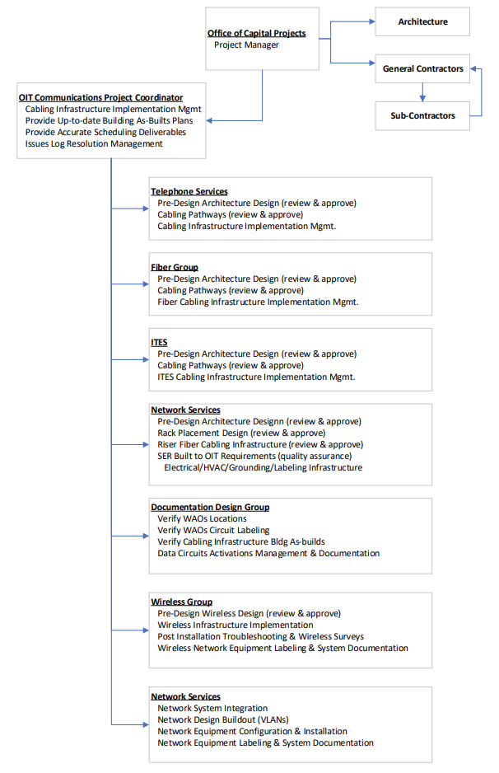

**Figure 1: Communication Workflow**

1. **Architectural Drawings Requirements**



**T-Drawings**

Telecommunications drawings shall be identified as “T” series (Telecommunications) drawings in the approved construction drawings, separated from “E” (Electrical) drawings. The T-series drawings shall include:

* Floor layout, showing work outlets, cable path (j-hooks or cable tray, horizontal and riser), sleeves, conduits.
* Legends using industry standard symbols
* Satellite Equipment Room (SER) layout / elevations
* Equipment rack layout
* Detailed Work Area Outlet (WAO) with labeling
* Riser diagram and cabling for voice, data and cable television (CATV)
* Outside plant, cabling, methods and paths, with footages and bends
* Schedule of jacks and rooms
* Pull Box detail

**As-Builts Drawings**

As-builts drawings are documents that allow a compare and contrast between the designed versus final specifications, and provide a detailed blueprint of the building and the land around it as actually constructed in the end. As-builts are important for four main reasons:

* **Improves the renovation process:** With a full history of project changes, owners can see exactly what has been built and do not have to invest heavily in learning about existing conditions.
* **Assists the facilities team:** With a full record of change, facility teams can meet issues faster and owners can save money down the road due to improved operations and speed.
* **Improves onboarding:** As subcontractors are added to a project, delivering a set of as-builts helps teams get access to the right information quickly, which allows getting up to speed starting work sooner.

**As-builts During Construction Requirements**

The revised set of drawing **as-builts during construction** shall be submitted by the contractor **due upon completion of cabling of each floor, to include all data cabling, with its’ unique identification label.** The Telecommunications As-builts series **drawings shall reflect all changes made in the specifications and working drawings during the construction process** (Adds, Deletions, and Up-to-date change orders).

* Drawings shall include the following:
  + **Floor layout, showing work outlets, cable path** (j-hooks or cable tray, horizontal and riser), sleeves, conduits **using industry standard symbols**
  + **Detailed Work Area Outlets (WAO) with labeling**
* Must be **indelible and printed** (hand written documentation is not acceptable)
* **Submitted in both in hard and electronic versions** to OIT Project Coordinator

**Final As-built Requirements**

The **final as-built drawings** include any and all of the following, as well as every other change made during the construction phase of a project, includes modifications, field changes, shop drawing changes, design changes, and extra works. The revised set of drawing shall be submitted by the contractor **upon completion of a project or a particular job**. The Telecommunications As-builts series **drawings shall reflect all changes made in the specifications and working drawings during the construction process** (Adds, Deletions, and Up-to-date change orders).

* Show the exact dimensions, geometry, and location of all elements of the work completed under the contract to include:
  + Show the exact location of all ports labeled with its unique cabling identification.
  + Show a break identifying the ports feeding back to the SER in which it services.
* Drawings will include wireless access point and camera locations.
  + Camera field of view, and camera name or MAC address
  + Wireless Access Point MAC address
  + Shall be included in the document
* **Provide all test results and Final As-Built drawings at the time of project completion**,
  + Must be **indelible and printed** (hand written documentation is not acceptable)
  + **Submitted in both in hard and electronic versions** to Facilities Services.
  + A courtesy copy of all documents should be provided directly to OIT Project Coordinator.
* Electronic copies of test results should be in XLS or PDF format (as appropriate).
* Drawings should be in a Visio compatible format .DWG files are acceptable as an alternative.

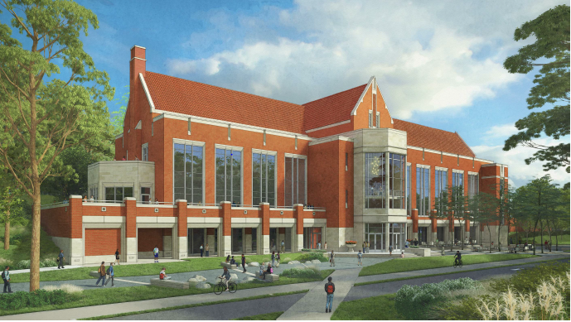

1. **Variances**



The architect shall prepare the Design Development Documents from the approved Schematic Design. The Design Development Documents shall consist of drawings and other documents, including specifications to fix and describe the size and character of the entire project as to kinds of materials, type of structure, mechanical and electrical systems, and other work that may be required for construction of the project.

**If requirements cannot be met during the design, then a “OIT Standard Requirements Variance Form”** (see Appendix F) **must be completed and sent to the UTK Facilities Services Project Manager and approved by the OIT Communications Director**. A copy must also be sent to the OIT Communications Assistant Director, OIT Network Manager, Telephone Services Manager and the OIT Project coordinator. **UTK OIT will review the request and either accept, modify or deny the variance and will notify the requestor**.

1. **MDF/IDF Usage and Restrictions Requirements**

OIT typically refers to the Satellite Equipment Room as an SER. It may also be referred to as a Telecommunications Room (TR), Intermediate Distribution Frame (IDF), Main Distribution Frame (MDF), or Uplink Room. The SER houses the terminations of horizontal and backbone cabling and its interconnects to the necessary hardware.

**Use and Restrictions**

* SERs shall be dedicated to telecommunications functions and related support facilities.
* If the SER is to contain other systems, including but not limited to audio-visual (A/V) equipment, fire alarm panels, building management systems, cable tv, camera systems, or computer servers, usage shall be approved by the OIT Chief Information Officer or his/her delegate prior to construction.
* **No SER shall be used as passageways to other equipment rooms, power transformers, custodial equipment, or any other function that would require access for reasons other than service and maintenance of the communication equipment and cabling they house**.
* **Measures must be taken to prevent water intrusion, sewer, chemical, or drain piping of any kind, shall not be routed through/within a SER**.
* **Equipment not related to the support of the SER** (e.g., piping, ductwork, pneumatic tubing, etc.) **shall not be installed in, pass through, or enter the SER**.
* SERs shall not be shared with electrical equipment, building services, or other equipment.
* If other systems are installed, then space requirements must be increased by at least 20% as determined by OIT.
* It is not recommended by UTK OIT to house other services in the SER due to network security.
* **Unauthorized port activations are** **NOT PERMITTED**.
* **Equipment must remain powered on once installed**. If equipment is to be turned off, notification must be given prior to interruption to OIT Network Operations, University of Tennessee Police Department, and Facilities Services.

1. **MDF/IDF Design Requirements**

The SER shall be designed and provisioned per ANSI/TIA-569-C-1 Commercial Building Standards for Telecommunications Pathways and Spaces and per the BICSI Telecommunications Distribution Methods Manual (TDMM) current edition. There **shall be, at minimum, one SER per building**.

**Location within the Facility**

There are several of factors that need to be considered when placing SERs within new or remodeled facilities. Site selection factors for the various rooms are addressed below. Of these factors, the two most important are “stacking” of the spaces and providing a location that would allow the spaces to be expanded, if required, in the future.

* Horizontal location(s): The SER shall be centrally located within the floor area it serves in order to maximize the number of horizontal cable plant WAO connections it can service. The maximum cable length allowed from the SER termination to that cable’s **WAO termination is 295 feet** (90 meters).
* Vertical Location(s): In multi-story buildings requiring multiple SER rooms, the **SER rooms shall be in vertical stack alignment**.
* Avoid locations that limit expansion such as structural steel, stairwells and elevator shafts, outside walls, or other fixed building walls.
* SERs **should be easily accessible and accessed directly from public hallways**. Access should not be through offices, bathrooms, other utility spaces or janitorial spaces.
* SERs **should not service WAOs on more than one floor**.
* SERs and the cabling they support shall be separated from sources of electromagnetic interference such as induction devices, transformers, ballasts, power supplies, elevator equipment, generators, motors, X-ray generators, photo copiers, microwave ovens, and similar equipment nor be located near sources of mechanical vibration.
* The location of SERs **shall allow easy access** to cable distribution pathways.
* SERs shall not be in any place that may be subject to water or steam infiltration, humidity from nearby water or steam, heat, and any other corrosive atmospheric or environmental conditions.

**Size**

The size of the SER is dependent upon the size of the area that the room will serve, and the variety of equipment installed within the room. The SER shall provide enough space for all planned terminations, electronic equipment, and cables that will be installed within the telecommunications room; including any environmental control equipment, power distribution/conditioners, door access controllers and other security systems, in-building cellular equipment and uninterruptable power supply systems.

* If the floor serving area is 5,000ft2 or less, size the room 10’X10’
  + Minimum 2 horizontal rack management layout design
* If the floor serving area is 5000ft2 to 8,000ft2, size the room 10’X12’
  + Minimum 2 horizontal rack management layout design
* If the floor serving area is 8,000ft2 to 10,000ft2, size the room 10’X16’
  + Minimum 3 horizontal rack management layout design
* If serving over 10000 ft2 an additional SER is required.
* If a second SER is required to manage the horizontal cable placement run distance limit of 90 meters, size the second SER per the guidelines above.

**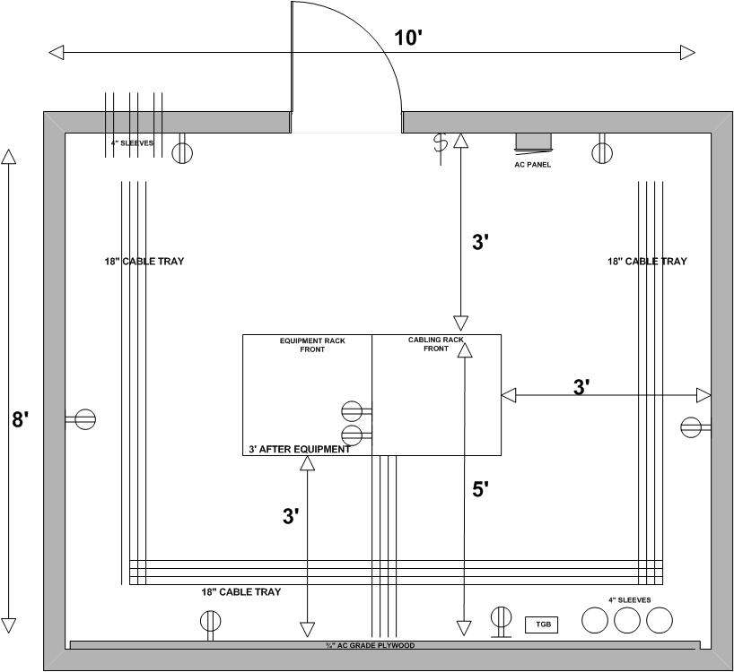**

**Figure 2: Typical SER Layout**

**Shape**

SER must be a **rectangular room with no obstructions or protrusions** (beams, columns, etc.) that decrease the usable square footage available in the room.

**Room Layout**

* A minimum of 18” wide ladder rack shall be installed around room and to each rack.
* Cable tray shall be bonded per ANSI/TIA 607-D-1 and NEC
* The ladder rack and cable tray should also be anchored to the top of each equipment rack as each is installed.

**Waterfalls**

* The use of waterfalls is recommended for use with all wire cable trays and ladder racks to maintain an adequate bend radius.

|  |  |  |
| --- | --- | --- |
|  |  |  |

**Figure 3: Typical use of Waterfalls**

**Riser Pathway**

* Riser pathway interconnects the SERs in a building.
* When more than one IDF will be needed in a building, four (4), four-inch (4") sleeves will be installed from the MDF to the first IDF. Then each IDF will connect to the one above it with two (2), four-inch (4") sleeves.
* When the SERs are stacked this requirement is easily accomplished using only conduit riser sleeves floor/ceiling penetrations from one IDF to the next.

**Door**

* Doors shall be a minimum of 36” wide and 7’6” tall.
* Door must be solid and contains no windows.
* If designed with double doors, the center must be removable.

**Room Access**

Due to the sensitivity of the data contents and the availability requirements of the connected devices on the university network, all SERs must be secured at all time.

* SER doors shall be secured using card access/readers.
* The rooms must be accessible during power outages.
* SER door lock keyed to "XZMA".
* Unauthorized use of the room is prohibited.

**Enclosing Walls**

* SER walls shall extend to the structural ceiling above.
* All penetrations in rated SER walls shall be fire stopped.
* The walls and ceiling of the SER shall be painted in light colored paint.

**Windows**

* SERs shall not have windows.

**Floors**

* SER floors should be floor slab, no raised or false floor.
* Floor finish shall be smooth, dust-free, and not susceptible to static electricity build-up.
* Acceptable finishes are to be light in color and be either vinyl composition tile (VCT), low static composition tile, static dissipating tile (SDT), or sealed concrete.

**Ceiling**

* No false (lay-in tile) or hard lid ceiling shall be installed over any SER floor space.

**SER Electrical Sub-Panel**

* A separate supply circuit serving the SER shall be provided and terminated in its own electrical panel inside the SER.
* The sub-panel should be located on the inside of the SER near the room entrance door and should be connected to an Emergency power source.
* Emergency power is required in SERs as they house telephone systems and network switches that support life safety, security, and other critical systems.

|  |  |
| --- | --- |
|  |  |

**Figure 4: Typical Panel Designation and Labeling**

* The estimated electrical load for the telecommunication space shall not exceed 80% of the panel capacity.
* No power outlets outside the SER shall be serviced by this panel.
* All power circuits that supply outlets that support electronic shall be individual branch circuits from their breaker in the SER sub-panel to the outlet receptacle supplying the electronics.
* It is required that the electrical feed to the SER be backed up by a generator to conform with current National Fire Protection Association (NFPA) code.
* Outlets and faceplates with a generator feed **shall be red and labeled with the panel designation and breaker position of the servicing electrical panel**.

|  |
| --- |
|  |

**Figure 5: Typical Generator Feed Outlet Identification**

**Emergency Powered Outlets**

* A **minimum of two duplex electrical outlets mounted above the equipment rack** in 4”x4” box is required. These outlets **shall be 20amp, 120V non-switched, 5-20R receptacles on separate branch circuits for equipment power**.

|  |  |  |
| --- | --- | --- |
|  |  |  |

**Figure 6: Typical Rack Outlet Installation**

**Optional Stand-by Powered Outlets**

* Separate quad 120v ac **convenience outlets** for tools, test equipment etc., are to be **placed at maximum of 6’** (wall space) **intervals around perimeter of room and below the plywood**.
* All power, including power to all mechanical systems, in the SER shall be installed to the buildings generator.
* If other systems, as noted in the Use and Restrictions section, are installed electrical requirements must be provided for those systems.
* **In SERs that contain more than 150 WAOs, additional power may be required** as determined by OIT.

**Lighting**

* Coordinate the lighting layout with equipment layout, especially cable trays.
* Locate light(s) at a **minimum of 8.5’ above finished floor**.
* All **SER lighting shall be connected to Emergency power**.
* Power for **lighting should not come from the power panel located inside the SER**.
* SER should be **equipped with a** **manual on/off switch inside the room**.
* Provide a **minimum of 50’ candle measured 3’ above finished floor** on all sides of the rack equipment.

**HVAC Requirements**

The guideline for **temperature** of all MDF and IDF rooms **must be maintained between 64° and 75°F**. The relative humidity range must be between 30% and 55%. A minimum of 20,000 BTUs of cooling is required. A **thermostat located shall be installed in all MDF and IDFs** and placed 5' 0" above the finished floor to control the cooling system. Actual air handling requirements may exceed these guidelines **and should be calculated based on potential heating and cooling demand associated with equipment which may be present in the telecommunications entrance room**, including, but not limited to electronic equipment (ex. network switches, firewalls uninterruptible power supplies, video distribution equipment, file servers, coaxial amplifiers) and the building DAS infrastructure.

HVAC system shall be provided on a 24 hours-per-day, 365 days-per-year basis. It is required that the SER’s HVAC be tied into the Emergency power. The HVAC systems shall not use the same electrical panel that is used to support the outlets servicing the electronics housed within a MDF/IDFs. Drainage systems for HVAC units shall not pass above equipment and shall tie into the building drainage system. If a pump is needed to drain HVAC, it must be powered by emergency power.

**Wall Plywood Sheeting**

* **All walls shall be covered with 4’X8’, ¾” thick Fire Rated Grade A-C plywood**, certified as fire retardant and the Grade A rated side facing outward.
* Plywood should be **painted with two coats of white fire-retardant paint**.
* Plywood shall be **above electrical outlets** (17” above finished floor typical) and **extend to above cable tray**.
* The contractor shall be responsible for getting the plywood approved by the fire marshal before painting.

**Sprinkler Systems**

* Do not install sprinklers directly above the equipment racks.

**Ground**

Telecommunications grounding and bonding systems shall be installed to support the telecommunications infrastructure. The requirements for this system are specified in ANSI-J-STD-607-D-1: The Commercial Building Grounding (Earthing) and Bonding Requirements for Telecommunications.

The telecommunications grounding and bonding system starts with a physical connection to the building grounding electrode system and extends to every telecommunications room (SER) in the building.

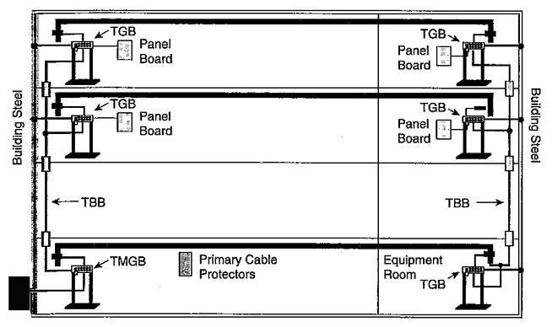

**Figure 7: Typical Grounding Configuration**

* **Create continuity with each rack and the cable tray by bonding each rack and cable tray to the Telecom Grounding Busbar** (TGB).
* **Label all connectivity to the TGB** according to the BICSI Telecommunications Distribution Methods Manual (TDMM), latest edition.

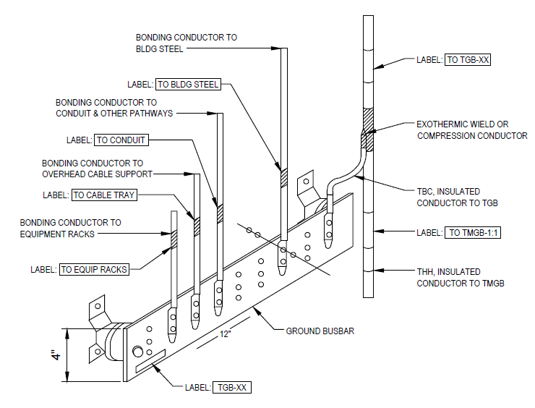

**Figure 8: Typical Ground Continuity Configuration**

**Firestopping**

Firestopping is the process of installing an approved firestopping system to stop the progress of fire along the cable pathway through fire-resistance rated walls, partitions, floors or ceilings. Approved firestopping methods and materials must be used to significantly reduce the possibility of spreading fire, smoke, and toxic gases throughout a building.

* This is a life safety issue enforced by national and/or local code.
* **Refer to the applicable codes to determine the requirements** and then follow the firestopping system manufacturer’s instructions for proper installation.

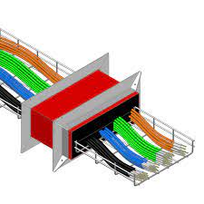

1. **MDF/IDF Rack Layout Requirements**

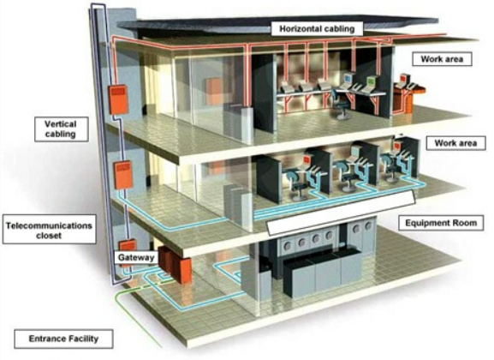

A SER houses the terminations of horizontal and backbone cables to connecting hardware including any jumpers or patch cords. It may also contain the interconnect (IC) or main cross-connect (MC) for different portions of the backbone cabling system. The SER also provides a controlled environment to house telecommunications equipment connecting hardware and splice closures serving a portion of the building. The use of a telecommunications enclosure (TE) is for a specific implementation and not a general case. It is intended to serve a smaller floor area than a SER and may be used in addition to the minimum "one SER per floor" rule.

**Required Rack Design Layout**

* There will be a **minimum of three network racks** with 6-inch-deep vertical wire management per SER.
  + Horizontal Cable Management Rack
  + Network Electronics Management Rack
  + Horizontal Cable (Future Cables) Management Rack
* Each rack has a footprint of 3’X3’X7’6”’ and shall be bolted and bonded together.
* The ladder rack and cable tray should also be anchored to the top of each equipment rack as each is installed.
* There shall be a **minimum of 3 ft. clearance around all sides of the connected racks**, measured from equipment mounted on wall, not the wall itself. **Install appropriate 48-port patch panels** (only) **in the cabling rack** and the fiber optic patch panel in the network electronics rack.
* **Copper riser cables for analog telephone service should be terminated in an RJ-45 patch panel**.

The number of racks in the SER is dependent upon the size of the area that the room will service, and the variety of equipment installed within the room.

* If the SER room size is 10’X10’ and floor serving area is 5,000ft2, there is a minimum 2 rack design configuration.
* If the SER room size is 10’X12’ and floor serving area is 5000ft2 to 8,000ft2, there is a minimum 3 rack design configuration.
* If the SER room size is 10’X16’ and floor serving area is 8,000ft2 to 10,000ft2, there is aminimum 3 rack design configuration.

If a second SER is required to manage the horizontal cable placement run distance limit of 90 meters, size the second SER per the guidelines above.

|  |  |  |  |
| --- | --- | --- | --- |
| **SER Main Distribution Frame (MDF)**  **Typical MDF Racks Configuration**  **C:\Users\Thoma\AppData\Local\Microsoft\Windows\INetCache\Content.Outlook\NOINTXJ1\Typical rack layout - MDF-10-JAN-2023.png**  **Figure 9: Typical MDF Racks Configuration** | | | |
| **Rack 1**  **Fiber Plant Cable Management** | **Rack 2**  **Horizontal Cable Management** | **Rack 3**  **Network Electronics Management** | **Rack 4**  **Horizontal Cable Management** |
| **2RU horizontal cable manager** shall be placed **above** OSP Fiber Demarc patch panels.  OSP Fiber Demarc patch panels are to be mounted in the top of the rack.  4RU Fiber Panels shall be used for MDF SER to service the outside fiber plant to the inside the building fiber plant infrastructure. | **2RU horizontal cable manager** shall be placed **above and below** each voice cross-connect patch panel.  Mount 2RU, 48-port voice cross-connect patch panel (**voice circuits 1–48**) above the WAO station cable patch panel. The number of voice cross-connect jacks shall be equal to the number of pairs in the voice riser cable pair count.  Only 2RU, 48-port panels will be used for horizontal cabling.  **2RU horizontal cable manager** will be placed **above and below** each copper patch panel.  No more than five (8) 48-port station cable patch panels (**data *circuits 1–384***) will be placed in a rack. | **2RU horizontal cable manager** shall be placed **above** riser patch panel.  **Rack mounted ground bar** (rear or rack)  2RU Riser Fiber Patch Panel is to be mounted in the top of the rack.  Network electronics such as edge switches, uplink switches, and firewalls.  Uninterrupted Power Supply (UPD) with network interface card installed  MicroPod Power Distribution Unit | **2RU horizontal cable manager** will be placed above and below each copper patch panel.  Only 2RU, 48-port panels will be used for horizontal cabling.  No more than ten (10) 48-port station cable patch panels (**data *circuits 385–816***) will be placed in a rack.  No patch panels should be installed below 12 inches from the floor.  Rack will be appropriately grounded.  Minimum 3 feet clearance on all sides of the rack. |

|  |  |  |
| --- | --- | --- |
| **SER Intermediate Distribution Frame (IDF)**  **Typical IDF Three Rack Configuration**  **C:\Users\Thoma\AppData\Local\Microsoft\Windows\INetCache\Content.Outlook\NOINTXJ1\Typical Rack Layout - 3-10-JAN-2023 (002).png**  **Figure 10: Typical IDF Three Racks Configuration** | | |
| **Rack 1**  **Horizontal Cable Management** | **Rack 2**  **Network Electronics Management** | **Rack 3**  **Horizontal Cable Management** |
| **2RU horizontal cable manager** shall be placed **above and below** each voice cross-connect patch panel.  Mount 2RU, 48-port voice cross-connect patch panel (**voice circuits 1–48**) above the WAO station cable patch panel. The number of voice cross-connect jacks shall be equal to the number of pairs in the voice riser cable pair count.  Only 2RU, 48-port panels will be used for horizontal cabling.  **2RU horizontal cable manager** will be placed **above and below** each copper patch panel.  No more than five (8) 48-port station cable patch panels (**data *circuits 1–384***) will be placed in a rack.  No patch panels should be installed below 12 inches from the floor. | **2RU horizontal cable manager** shall be placed **above** riser patch panel.  **Rack mounted ground bar** (rear or rack)  2RU Riser Fiber Patch Panel is to be mounted in the top of the rack.  Network electronics such as edge switches, uplink switches, and firewalls.  Uninterrupted Power Supply (UPD) with network interface card installed  MicroPod Power Distribution Unit | **2RU horizontal cable manager** will be placed above and below each copper patch panel.  Only 2RU, 48-port panels will be used for horizontal cabling.  No more than ten (10) 48-port station cable patch panels (**data *circuits 385–816***) will be placed in a rack.  No patch panels should be installed below 12 inches from the floor.  Rack will be appropriately grounded.  Minimum 3 feet clearance on all sides of the rack. |

|  |  |
| --- | --- |
| **SER Intermediate Distribution Frame (IDF)**  **Exception - IDF Two Rack Configuration**  C:\Users\Thoma\AppData\Local\Microsoft\Windows\INetCache\Content.Outlook\NOINTXJ1\Typical rack layout -2-10-JAN-2023 (002).png  **Figure 11: Exception IDF Two Racks Configuration** | |
| **Rack 1**  **Horizontal Cable Management** | **Rack 2**  **Network Electronics Management** |
| **2RU horizontal cable manager** shall be placed **above and below** each voice cross-connect patch panel.  Mount 2RU, 48-port voice cross-connect patch panel (**voice circuits 1–48**) above the WAO station cable patch panel. The number of voice cross-connect jacks shall be equal to the number of pairs in the voice riser cable pair count.  Only 2RU, 48-port panels will be used for horizontal cabling.  **2RU horizontal cable manager** will be placed **above and below** each copper patch panel.  No more than five (8) 48-port station cable patch panels (**data *circuits 1–384***) will be placed in a rack.  No patch panels should be installed below 12 inches from the floor. | **2RU horizontal cable manager** shall be placed **above** riser patch panel.  **Rack mounted ground bar** (rear or rack)  2RU Riser Fiber Patch Panel is to be mounted in the top of the rack.  Network electronics such as edge switches, uplink switches, and firewalls.  Uninterrupted Power Supply (UPD) with network interface card installed  MicroPod Power Distribution Unit |

|  |  |
| --- | --- |
| **SER Intermediate Distribution Frame (IDF)** | |
| **Exception - IDF One Rack Configuration** | |
|  |  |
|  | **2RU horizontal cable manager** shall be placed **above** riser patch panel.  **Rack mounted ground bar** (rear or rack)  2RU Riser Fiber Patch Panel is to be mounted in the top of the rack.  **2RU horizontal cable manager** shall be placed **above and below** each voice cross-connect patch panel.  Mount 2RU, 48-port voice cross-connect patch panel (**voice circuits 1–48**) above the WAO station cable patch panel. The number of voice cross-connect jacks shall be equal to the number of pairs in the voice riser cable pair count.  Only 2RU, 48-port panels will be used for horizontal cabling.  **2RU horizontal cable manager** will be placed **above and below** each copper patch panel.  No patch panels should be installed below 12 inches from the floor.  Network electronics such as edge switches, uplink switches, and firewalls.  Uninterrupted Power Supply (UPD) with network interface card installed  MicroPod Power Distribution Unit |

**Figure 12: Exception IDF Single Rack Configuration**

**Emergency Powered Electrical Outlets Above the Rack**

* A minimum of two duplex electrical outlets mounted above the equipment rack in 4”x4” box is required. These outlets shall be 20amp, 120V non-switched on separate branch circuits for equipment power mounted above each rack.

|  |  |  |
| --- | --- | --- |
|  |  |  |

**Figure 13: Typical Rack Outlet Installation**

**Equipment Location**

The layout of any non-OIT network equipment within the OIT MDF and IDFs must be approved in advance by the OIT Project Coordinator. This includes DAS equipment, camera or NVR systems, fire panels or other life safety equipment, etc. No non-OIT network equipment is to be plugged into OIT designated emergency power outlets. If emergency power is required a separate circuit will need to be installed.

**Ground**

SER grounding and bonding system shall be installed to support the telecommunications infrastructure. The requirements for this system are specified in ANSI-J-STD-607-D-1. The Commercial Building Grounding (Earthing) and Bonding Requirements for Telecommunications.

* Each rack will be appropriately grounded.
* **Each rack shall be bonded to the rack mounted busbar**
* OIT requires a ground lug on the rack capable of being used as a splicer.
* There must be at least one unused connector hole that can accept #6 - #14 wire.
* **Bonding terminal must be a two-hole design**.

|  |  |
| --- | --- |
|  |  |

**Figure 14: Typical Grounding and Bonding System**

1. **Outside Plant (OSP) Pathway Requirements**

Before designing the OSP, the designer and/or consultants will need to meet with UTK OIT for system requirements and methods. Most OSP at UTK is underground and in conduit. Aerial and direct bury cables must receive prior approval by the UTK OIT Project Coordinator.

**Underground requirement**

* 4” PVC Schedule 40 conduit only between Handholes (HH) and into buildings.
* 4” PVC Schedule 80 conduit under parking lots, streets, and driveways encased in concrete with warning tape on top of encasement.
* A **minimum of 30” from top of conduit to finished grade**.
* **Minimum of 12“separation from electrical power, 24” from steam lines**.
* Minimum of four 4” conduits from Handholes (HH) to HH with 2 of the four conduits to have 4 3X3 **DETECTABLE** MaxCell installed.
* Minimum of three 4” conduits from HH to Building. UTK OIT will determine if more are required.
  + At least one of the 4” conduits is to have 3 3X3 **DETECTABLE** MaxCell installed.
  + Each MaxCell is to have different color ID markings and be locatable.
  + Plastic flexible inner duct not allowed.
* **All conduits** (including when filled with MaxCell) **are to have a pull rope** (no strings) installed.
* **Conduits entering the buildings must be sloped away from building**.
* HH’s are to be manufactured by Quazite, open bottom (on top of 4” of rock), and with a minimum size of 30”X 48”, cover labeled “Communications”.
* Cover to have pull slot with center pin.
* HH covers are to be heavy duty and be traffic/drive overrated.
  + Manholes shall be a minimum of 7’X7’X7” inside dimensions and should be manufactured in top and bottom halves.
  + Each manhole shall be equipped with steps and ladders.
  + They shall have racks in all 4 corners mounted to corner brackets and 2 racks equally spaced on each side wall which are mounted on S brackets.
* HH’s are to be installed at a maximum distance of 150’ intervals for straight runs. This distance could be shorter after calculating bends and cable pulling tensions.
* **No 90° bends in conduit**. Communications sweeps are to be used.
* No “elbows or LB’s” (Smart LB allowed, see figure below), **terminate conduit in an appropriately sized pull box** (PB).

|  |
| --- |
| **smart.jpg** |

**Figure 15: Front View of Racks LayoSmart Conduit Body – Telecommunications LB**

* When tying into an existing HH, first consult with UTK OIT to determine if a HH needs to be replaced with a larger size.
* When entering a HH, enter at bottom, do not drill or punch holes in sides of HH.
  + Any exceptions to this must be cleared with UTK Telecommunications.
  + A HH is not to be used in lieu of a bend.

|  |
| --- |
|  |

**Figure 16: Pull Box Configurations**

* **Conduits are to be free of debris and water**.
* **Notify UTK OIT when conduits are ready to be sealed**.
* Cabling is to be neat and professional inside HHs & PBs.
* Route and secure cables around edges to free up room for future cabling.
* **All cables are to be labeled inside HH or PB**. Consult UTK OIT.
* Every other HH is to have a **25’ maintenance loop for fiber optics**. Secure loop to side of HH.
* Install “Caution Telecommunication” detectable Orange tape, along the cable pathway 12” below the final grade.
* When splicing is necessary; use approved splicing methods and enclosures.
* All **coax connectors are to be enclosed with heat shrink, with at least 2” of shrink tube** covering outer jacket.
* Use flame spread head to avoid scorching and melting center dielectric.
* **Consult with UTK OIT before any splicing** is designed or requested.
* **Before back fill, all underground installations must pass UTK OIT inspections**.

1. **Inside Plant (ISP) Cabling Infrastructure Requirements**

**Backbone Cabling**

The campus backbone is the network foundation. It connects the buildings across campus to create the network computing environment. It includes the inter-building and intra-building cable connections in structured cabling between entrance facilities, equipment rooms and telecommunications closets. Backbone cabling consists of the transmission media, main and intermediate cross-connects and terminations at these locations.

**Riser Telecommunications Copper Cables**

These cables shall terminate on the backboard beside the entrance protectors in the main SER (MDF).

* Copper riser cable sizes shall be determined on a per building basis.
* Copper riser cables shall be ARMM cable.
* **The cables shall be bonded**.

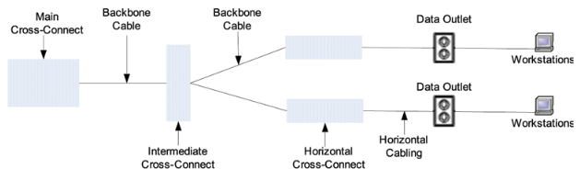

**Figure 17: Typical Riser Copper Configuration**

|  |
| --- |
|  |
| **Figure 18: Multi-Pair Copper Backbone Diagram** |

* **100 Pair between ground floor telecom room and** **TMH**.
* (1) **25 Pair ARMM type cables to each SER**.

**Analog Cabling Deployment**

**OSP cabling to terminate within 50’ of entry in MDF on protection. 25 pair riser cables shall be home run from MDF to each SER and landed in rack as designated in rack layout.** 25 pair riser cable should be placed in MDF equipment rack. **Riser cable shall be wall mounted on 110 blocks in MDF and labeled**.

|  |  |
| --- | --- |
|  |  |

**Figure 19: Typical Analog Cabling Deployment**

**Riser Fiber Optic Cables**

* Fiber patch panels are to be mounted in the rack where the network electronics are to be installed.
* Fiber optic riser cables shall be riser rated single mode manufactured by Corning.
* Cables shall be terminated with Corning LC Unicom connectors.

|  |
| --- |
| **Figure 20: Typical Riser Fiber Backbone Diagram** |
| * **48 Strand Single Mode Optical Fiber cable** extended between ground floor telecom room and OIT designated SER Room. Coordinate cable routing and FDU termination locations with the OIT Project Coordinator. * **24 Strand Single Mode Optical Fiber cable between SERs**. Terminate cable in FDU on rack in each SER. * Terminate Optical Fiber Strands using **LC type connectors** and adapter panel plates. * **6 Strand Single Mode Optical Fiber cable between SER and WAN FACP**. |

**Horizontal Cabling Deployment**

The horizontal cabling system extends from the work area’s telecommunications information outlet to the SER. It includes horizontal cable, mechanical terminations, jumpers and patch cords located in the SER and may incorporate multiuser telecommunications outlet assemblies (MUTOAs) and consolidation points (CPs).

Prior to design, the designer and or consultant must meet with UTK OIT to determine applications, methods and material. All new construction and full remodels are required to use Cat6 cabling **(**100-ohm UTP CAT6) for both voice and data.

* Terminations
  + All terminations shall be done to **T-568A** scheme

|  |  |  |
| --- | --- | --- |
|  |  |  |

**Figure 21: T568A Scheme**

* Slack Storage / Service Loops
  + **Above the WAO in the ceiling,** 1m (**3.28’**), and **at the WAO for termination 8”**.
  + **Cable slack should not be stored in bundled loops**. Cable loops have a degrading effect on cabling performance.
  + **Cable slack should be stored in an extended loop or in a figure-eight configuration**.
  + **Do not exceed** the BICSI maximum **bend radius** for premises cable (**of 4 inches**).
  + No splices in telecommunications cabling.
  + Flexible metallic conduit or plastic tubing not allowed.
* Bundling
  + Cables of different categories **should not** be bundled together
  + Cables **should not** be tightly bundled anywhere
  + The use of ty-wraps is to be avoided. **Hook and loop ties are preferred**.
  + If ty-wraps are required, their use must be pre-approved by the OIT Project Coordinator.

**Elevator Traveling Cable**

|  |  |
| --- | --- |
| Elevator traveling cable is a **vital link between the elevator car and controller.** In conventional elevators, all power and signal information is transmitted through the traveling cable. The vast majority, as much as **95%,** of wire and cable produced will be installed in a fixed location. When the elevator installer / manufacturer orders the traveling cable they can add a Cat6 or RG6 for cameras. The traveling cable is a specialty made cable.  **The travel cable needs to have (3) 22 gauge shielded cables for future network needs.** |  |

**Figure 22: Sample Elevator Traveling Cable**

**Camera in the Elevator**

CCTV Project for elevators usually needs to face the difficulty of**running cables**. Today having an camera in the elevator is very important for safety of the building people. Traditionally, cameras in the elevator is connected by wire that runs up and down with the elevator. For buildings taller than 10 stories, a wired solution can be dangerous.

* **Coax termination(s) on the wall in IDF or accessible room within scope of coax to PoE+ device (approximately 1000ft using RG-59 20AWG solid copper core cable).**
* **PoE/Coax converter mounted on the wall.**
* **CAT6 run from patch panel to jack on the wall – just another circuit**
* **Patch cable from wall jack to converter.**

|  |
| --- |
|  |

**Figure 23: Elevator Cabling PoE+ Over Coax Adapter Kit Sample**

|  |
| --- |
|  |

**Figure 24: Elevator Camera Installation Configuration Sample**

**Coaxial Cabling Deployment**

Prior to installation, the installer must meet with UTK OIT Project Coordinator and **seek the approval to determine the exact location of all equipment being mounted in the SER**.

* Location will be determined on a per SER building basis.
* These cables may be required to terminate on the backboard.

**DAS Cabling Deployment**

A distributed antenna system (DAS) is a group of antennas spatially separated and distributed over a given geographic area, such as a campus, to augment existing wireless (e.g., cellular, radio signal) service to be deployed within isolated areas of a building or series of buildings, to increase the ubiquity of coverage within the objective. The DAS may also be deployed to provide extra network capacity in venues that are infrequently used but are subject to high demand of wireless services such as stadiums, arenas, and auditoriums. Prior to installation, the installer must meet with UTK OIT Project Coordinator and **seek the approval to determine the exact location of all equipment being mounted in the SER**.

* Location will be determined on a per SER building basis.
* These cables may be required to terminate on the backboard.

**Audio Visual (AV) Cabling Deployment**

Prior to installation, the designer will need to **consult with UTK OIT’s Engineering Services (ITES) for design specifications** and the **UTK OIT Project Coordinator to** **seek the approval to determine the exact location of all equipment being mounted**.

* Location will be determined on a per building basis.
* These cables may be required to terminate on the backboard.

1. **Inside Plant (ISP) Cabling Pathway Requirements**

The backbone cabling provides interconnection between telecommunications rooms, equipment rooms, access provider (AP) spaces and entrance facilities. The pathway is designed to route and manage copper data cables, fiber optic cables, and power cables within connected buildings

**Horizontal Cabling Pathway**

These **primary horizontal cabling pathways should be routed following building lines and major floor access routes such as corridors and hallways**.

* They **should never cross over end user work areas** such as offices, conference rooms, or work cube areas.
* Access for cabling personnel and technicians that is sufficient for easy cable placement yet causes minimal disruption to floor occupants is an important design consideration when laying out the routing of primary horizontal cabling pathway.
* Any other structures, such as walls or joists that the cable passes through, must support the cable similarly (may require sleeves).

Cable Tray

* **Open wire cable tray is recommended** (versus enclosed cable trays)
* **Ladder Rack shall be used in MDF and SER installs**
* **Basket Tray shall be used in hallways**
* There **must be 12” free space above cable tray to allow access**
* Pathway cable tray installed **no more than 24” above ceiling height**
* **Cable tray shall be grounded and bonded** per ANSI/TIA 607-D-1 and NEC

|  |
| --- |
|  |

**Figure 25: Typical Cable Tray installation**

Waterfalls

* The use of waterfalls is recommended for use with all wire cable trays and ladder racks to maintain an adequate bend radius.

|  |  |  |
| --- | --- | --- |
|  |  |  |

**Figure 26: Typical Waterfall Installation**

Ladder Rack

* A cable ladder rack system routes networking cables along runways, keeping them organized along ceilings, walls, and floors.
* Cable ladder racks make reconfiguring or troubleshooting network connections efficient, while protecting wiring from elemental conditions.
* Provide simple and effective pathway solutions to easily manage and protect cables while maximizing network infrastructure uptime.
* Must meet ANSI/TIA installation guidelines for Category 6/6a and fiber cables.

|  |  |
| --- | --- |
|  |  |

**Figure 27: Typical Ladder Rack Installation**

Conduit

* Bends must accommodate the bending radius of the cable.
* No more than two 90 degrees bends in a cable run – pull boxes may be used to break up a run.
* **Pull boxes must be installed** in conduit runs **exceeding 100 feet**.
* Conduit segment **must not** exceed the allowable permanent link length.
* **Do not exceed maximum premises cable conduit fill ratios**.
* Coaxial cable **is not** to be housed in the same conduit as premises cables but may share the same cable tray.
* DAS cable **is not** to be housed in the same conduit as premises cables but may share the same cable tray.
* Use **plastic bushings on all conduit ends** to avoid damage to the cable.

|  |
| --- |
|  |

**Figure 28: Conduit with Required Bushing**

J-Hooks

* If J-Hooks are required, their use must be pre-approved by the OIT Project Coordinator.
* Regardless of the J-Hook’s manufacturer’s specifications, **no more than the maximum of 40 cables is allowed in any J-Hook**. (Do not exceed BICSI J-hook maximum fill ration)
* When there are more than 40 cables, then cable tray, wire basket or multiple J-Hook paths are required.
* **Space intervals and distribution for the use of J-Hooks should be 4’ to 5’** and anchor J-hooks to studs.
* J-hooks **should have beveled or rounded edges**

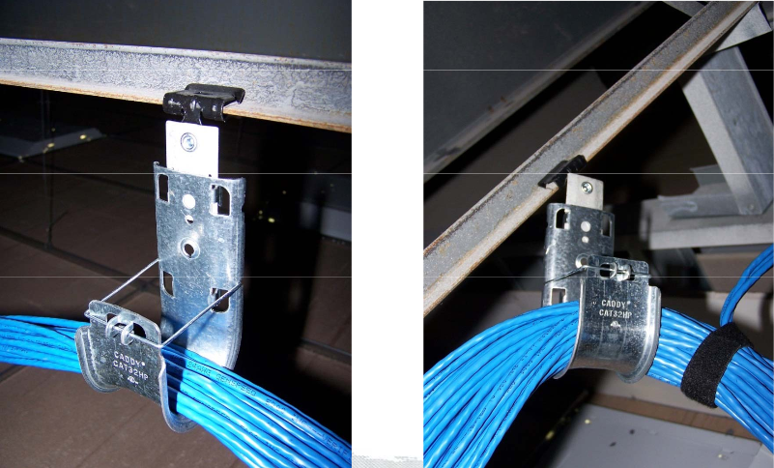

**Figure 29: Typical J-hook Installation**

Raceway

* Allows the flexibility to route connectivity to any room.
* Provides an attractive and cost-effective solution for concealing and protecting cables.
* The raceway can be cut, trimmed, and painted to fit virtually any décor and application layout.

|  |  |
| --- | --- |
| Image result for raceway with a hubbell surface mounted box for utp cabling | Image result for raceway with a hubbell surface mounted box for utp cabling |

**Figure 30: Typical Surface Raceway**

**Coaxial Cabling Pathway**

The coaxial cabling pathway used for visual purposes, especially televisions and VCRs **may share the same cable tray as premises cables** but **will not be housed in the same conduit as premises cables**.

* CATV cable must be RG-6 and terminated with snap and seal connectors.
* Amplifiers will be required for each floor.
* See the OIT Project Coordinator for current specifications and models.

**DAS Cabling Pathway**

The DAS cabling pathway **may share** the same cable tray as premises cables but **will not be housed in the same conduit as premises cables**.

**Audio Visual (AV) Cabling Pathway**

The audio visual (AV) cabling pathway used for multimedia purposes **may share the same cable tray as premises cables** but **will not be housed in the same conduit as premises cables**.

**Firestopping**

This is a life safety issue enforced by national and/or local code. **Refer to the applicable codes to determine the requirements** and then follow the firestopping system manufacturer’s instructions for proper installation.

1. **Work Area Outlets Requirements**

Work Area (WA) components extend from the telecommunications outlet/connector end of the horizontal cabling system to the WA equipment. A minimum of two telecommunications outlets (permanent links) should be provided for each work area.

**Work Area Outlets (WAOs)**

* **OIT views both analog and data circuits as a data circuit**.
* **All WAO must be equipped with the use of a junction box**.
* **Each WAO location shall have a minimum of 2 horizontal cables**.
* All **standard Cat6 data jacks to be yellow in color**.
* Special data circuits jacks **must not be** yellow, blue, or orange in color.
* The use of other type or color faceplates will be determined on a case by case basis and shall have prior approval from OIT.
* Requirements may vary for areas that support services such elevators, life safety (Code Blue Phones, etc.), security (cameras, NVRs), distributed antenna systems (DAS), and other multimedia.

|  |
| --- |
| Image result for hubbell utp 3 ports plastic keystone face plates |

**Figure 31: Typical Work Area Outlets Faceplates**

**Office, Administration, Conference Room, Lab and Classroom Spaces**

* **Minimum 3 ports per faceplate are used**.
* Each **office space is to have a minimum of two WAO’s, each with 3 cables** as specified by UTK OIT fed within a 1” conduit.
* Cable offices by, **routing cable to center of office before installing to WAO** so the cables can be used in either WAO.
* Department Heads that will actually occupy the space will need to be consulted with to insure their needs are met (***ex****. network printers and fax machine locations often get overlooked*).

**Mechanical, and Building Automation Spaces**

* **Minimum 2 ports per unit** are used.

**Conference Room Spaces**

* The designer will need to **consult with UTK OIT’s Engineering Services (ITES) for design specifications** for Conference Rooms.
* Each conference room shall have a **minimum of two WAO on opposite walls consisting of three CAT6 and one CATV cable**.
* Consideration should be given to floor mounted WAO under conference table for data, voice and multi-media to projector or screen.

**Break Room / Lobby Spaces**

* As a general rule, each break room area **should have one wall mounted WAO (ADA compliant)**.
* The Department Head should be consulted with for specific needs in their space.
* Lobbies and corridors may have wall mounted courtesy phones.
* Locate courtesy phones near elevators and or near main entrances /exits.

**Modular Furniture**

* **Minimum of 3 horizontal cables per workspace**.
* **No direct horizontal cabling**.
* Telecommunications and Power distribution planning should be coordinated to avoid conflicting pathway assignments.
* Untried distribution or terminations strategies should be avoided.
* **Permanent cables shall be installed only in or on permanent walls**.
* **All modular furniture shall be fed from a “Consolidation Point” (CP)**.
* Cabling from CP to modular furniture shall be through a power pole or through the wall if not blocked from furniture.
  + Locate CP in **an accessible area free from workstations and heavy file cabinets**.
* Label “Consolidation Point” with adhesive label on ceiling grid where the CP is installed.
* **Do not block access to horizontal cabling pathways or outlets**.
* **No cabling or WAO allowed behind modular furniture**.
* Designer must calculate the maximum cable capacity allowed in the modular furniture’s raceway and feed with multiple power poles if necessary.

|  |  |
| --- | --- |
|  |  |

**Figure 32: Typical Modular Furniture WAO**

**Residence Life / Housing Spaces**

* **Minimum of 2 horizontal cables**.
* A 2 port flat faceplates should be used when appropriate
* **Each student bed is to have one data cable**.
* **Each living room and bedroom shall have a minimum of one CATV outlet**. All CATV outlets shall be coordinated with UTK Telephone Services.
* **All RA and Hall Director housing units shall have in additional voice data outlets**. These shall be coordinated with UTK Telephone Services.
* When there is more than one CATV drop in a Housing unit, residential wiring scheme is permitted for CATV.
  + Run one CATV drop to unit and split signal to other outlets in unit through 1” conduits. Locate in wall box near electrical panel, secure splitter to back of box and bond to electrical panel with #14 AWG green insulated wire. The main entrances to a housing building shall be equipped with an outside weatherproof wall or pedestal mounted phone and located near card reader door access.

**Floor Boxes / Poke Thru**

* **Recessed multi-service concrete floor box 4” deep hinged lid** with a **minimum of 4 keystone openings** must be used.
* As a general rule, **must have a minimum of two horizontal cables**.
* **Outdoor rated cable must be used on all grade level slab floor boxes**.

|  |  |
| --- | --- |
|  |  |

**Figure 33: Typical Floor Boxes**

**Wireless Access Point (WAP)**

* WAP junction boxes **shall be at ceiling level and opening shall face downward**.
* WAP **junction boxes should not be placed within 3’ of a protection sprinklers head**.
* Typical installation **requires the WAP be mounted below the ceiling, including the ceiling grid**.
* **Standard 2 horizontal cables pulled inside a 4 square box with a single gang mud ring for all hard ceiling installation**.
* For all **drop ceilings installation where the WAP is mounted above the ceiling**:
  + Standard **2 horizontal cables pulled with a double surface mount box** (SMB), aka biscuit, **with a** **20‘ service loop** for future serviceability, moves, and changes.
  + An **orange sticker dot must be placed on the ceiling grid beneath the WAP** to indicate the location of the WAP

|  |  |
| --- | --- |
|  |  |

**Figure 34: Typical Surface Mount Box**

**Surveillance Camera(s)**

* Standard 2 horizontal cables pulled inside a **4 square box with a single gang mud ring for all hard ceiling installation**.
* Standard 2 horizontal cables pulled with a **double surface mount box (SMB),** aka biscuit, **for all drop ceilings installation** with **with a** **20‘ service loop** for future serviceability, moves, and changes.

|  |  |
| --- | --- |
| DomeIndoorSidecameras | Image result for raceway with a hubbell surface mounted box for utp cabling |

**Figure 35: Typical Surveillance Cameras using a Surface Mount Box**

**Digital Signage**

* **Standard 3 ports faceplate** are used.
* Shall have a **minimum of two horizontal cables and one CATV cable**.

|  |
| --- |
| IFP13W |

**Figure 36: Typical 3 Port Faceplate**

**Other Areas**

* Requirements may vary for all other areas including those that support services such elevators, life safety (Code Blue Phones, etc.), distributed antenna systems (DAS), and other multimedia shall be coordinated with UTK OIT Project Coordinator.

|  |  |  |
| --- | --- | --- |
| VOIP-200H3 | Viking E-1600-03B-EWP A.D.A. Approved Emergency / Elevator Phone with –  vikingtelecomsolutions | C:\Users\Thoma\AppData\Local\Microsoft\Windows\INetCache\Content.MSO\884109E5.tmp |

1. **Labeling Requirements**

Network cable labeling is similar to ensuring everyone involved in your network speaks the same language and anyone who comes in to augment or service your network can easily understand the architecture. **All WAO’s, patch panels, 110 blocks, conduits, trays, backbone cables, grounding, and racks shall be labeled with specific labeling scheme of UTK OIT**.

**Labeling Schematic**

The key factor of a good administration system is the component labeling. Records cannot be established and maintained without good labeling during and after installation.

**The label shall contain a unique identification**, as outlined in the documentation and/or drawing. **All labeling must be indelible and printed** or generatedby a Panduit PanTher LS8E or Panduit MS300 label maker. **All horizontal cabling must be Labeled with their destination at every termination**.

|  |
| --- |
|  |
|  |

**Figure 37: Data Circuit Labeling Schematic**

|  |  |  |  |  |
| --- | --- | --- | --- | --- |
| **OIT Communications Group**  **Data Cabling Infrastructure Labeling Requirements** | | | | |
|  |  |  |  |  |
|  | **Labeling Schematic** | **Minimum**  **Font Size** | **Labeling**  **Requirements** | **Example**  **Labeling** |
| **Rack** | First 6 digits | 36 point | Top center of the network rack | OEE230 |
| **Patch Panel** | Last 3 digits | 12 point | Label must be placed behind transparent cover | 053 |
| **UTP Horizontal Cable** | 9-10 digits | 12 point | Each horizontal cable must be individually labeled 2” behind keystone jack at every termination | OEE230053 |
| **Faceplate (WAO)** | 9-10 digits | 12 point | Label must be placed behind transparent cover | OEE230053 |
| **Surface Mount Box (WAO)** | 9-10 digits | 12 point | Label must be placed behind transparent cover | OEE230053  VEE230001 |
|  |  |  |  |  |
| **Fiber Breakout Box** | 9-10 digits | 12 point | Each fiber horizontal cable must be individually labeled | FEE230001 |
| **Fiber Horizontal Cable** | 9-10 digits | 12 point | Each fiber horizontal cable must be individually labeled 2” behind the keystone jack at every termination | FEE230001 |
| **Faceplate (WAO)**  **LC Keystone Jack** | 9-10 digits | 12 point | Label must be placed behind transparent cover | FEE230001 |
|  |  |  |  |  |
| **Light Pole** | 9-10 digits | 12 point | Label the inside of the access panel label and each horizontal cable individually | FEE230007 |
| **Handhold Box** | 9-10 digits | 12 point | Label the inside of the access panel label and each horizontal cable individually | FEE230011 |
| **Code Blue Pedestal** | 9-10 digits | 12 point | Label the inside of the access panel label and each horizontal cable individually | FEE230113 |
|  |  |  |  |  |
| **Time Clock Cabinet** | 9-10 digits | 12 point | Label the exterior surface of the time clock box, the double surface mount box (biscuit), and each horizontal cable individually. | OEE230111 |
| **Panels** (ex. cBoard, Alarm, CardAx, etc. | 9-10 digits | 12 point | Label the exterior surface of the panel, the double surface mount box (biscuit), and each horizontal cable individually. | OEE230253 |
|  |  |  |  |  |

***See Appendix G for additional picture sample labeling***

1. **Device Naming**

OIT Communications has developed standards for naming access point and cameras in both outdoor and indoor applications. **Please contact the OIT Communications Project Coordinator for naming guidance for each project**.

**The University of Tennessee**

**OIT Communications Device Naming Schematic (Indoor)**

|  |  |  |  |
| --- | --- | --- | --- |
| C:\Users\Apache II\AppData\Local\Microsoft\Windows\INetCache\Content.MSO\C82896DC.tmp | C:\Users\Apache II\AppData\Local\Microsoft\Windows\INetCache\Content.MSO\4EE2BE0B.tmp | C:\Users\Apache II\AppData\Local\Microsoft\Windows\INetCache\Content.MSO\C7961A36.tmp | Image result for aruba network access point |

Sample Camera Name: **CMF-230-03**

**Naming Schematic (Outdoor)**

For outdoor devices (cameras, wireless access points) the following schematic shall be used.

The first letter will denote the device type. The letter "**C**" for **cameras** and "**W**" for **wireless access points**. This will be followed by the two letter Network Services building code for the location of the network infrastructure to which the device connects. After these 3 or 4 characters there will be a hyphen "**-**". For instance wll- means a wireless access point connected to equipment in the Stokely Residence Hall Garage (ll).

The schematic following the hyphen will be determined by whether the device is attached to the exterior of a building or to a pole.

If the device is connected to a **pole**, this field will start with letter "**P**" and be followed by the Facilities Services pole identifier.

If the device is connected to a **code blue phone**, this field will start with the letters “**CB**” and be followed by the 5 digits phone extension assigned to the code blue phone.

If the device is connected to the **exterior of a building** this field will begin with “**EXT**”, followed by a two letters designation for the cardinal direction (NOT building north) of the exterior surface to which the device is attached. Use the following matrix for the two letters designation.

|  |  |  |
| --- | --- | --- |
| * **NO** - North | * **SE** - Southeast | * **WE** - West |
| * **NE** - Northeast | * **SO** - South | * **NW** - Northwest |
| * **EA** - East | * **SW** - Southwest |  |

This field will then be followed by a hyphen "**-**" and then a two characters numerical identifier beginning with 01 and incrementing by one as needed.

**Example A**:

* + A **camera attached to a pole having the ID of 09943** and connected to network switch in Fred Brown would be: **CFD-P09943-01**

**Example B**:

* + A **wireless access point attached to the west side on the exterior** of Alumni Gym would be: **WAG-EXTWE-01**

**Example C**:

* + A **second wireless access point attached to the west side on the exterior** of Alumni Gym would be: WAG-EXTWE-02

**Example D**:

* + An **access point attached to a code blue phone** connected via the Student Union would be: **WSU-CB65467-01**

**Appendices**

**Appendix A**

|  |  |  |
| --- | --- | --- |
| **University of Tennessee**  **Vendor Installation Compliance Signoff Sheet** | | |
| Tasks listed below are a summation of the requirements specified in the OIT requirements document. This is to ensure proper installation, compliance to TIA and ISO Cabling standards, and allow for easier, less costly moves, adds and changes. | | |
| **Building Project Name:** | | |
| **General Contractor:** | **Structured Cabling Installer:** | **Structured Cabling Coordinator:** |
| **Facilities Project Manager:** | **OIT Project Coordinator:** | **IT Administrator Assigned:** |
| **Substantial Completion:** | **Certificate of Occupancy Date:** | **Network Install Date:** |
| **Statement of Work:** | | |
| **SER Type:** | **Riser Fiber:** | **Riser Fiber Destination:** |
| **Structured Cabling Type:** | **Data Circuit Prefix:** | **No. of Data Circuits:** |

|  |  |  |
| --- | --- | --- |
| **Installers, Products & Materials** | | **Initial** |
| 1 | All installer(s) used on the project are BICSI Certified. |  |
| 2 | Only certified products and materials were used for the installation. |  |
| 3 | All installer(s) are current on training, certifications, and building electrical codes and standards. |  |
| **Installation** | | **Initial** |
| 1 | The use of plastic ty-wraps was avoided. |  |
| 2 | No cables are tightly bundled anywhere. |  |
| 3 | No splices in data communications cabling. |  |
| 4 | No Ethernet extenders were used during the installation. |  |
| 5 | All terminations are terminated using the **T-568A** scheme. |  |
| 6 | No cable bend radius exceeds the BICSI maximum of 4 inches. |  |
| 7 | Service loop of minimum 8” inches at the WAO for termination. |  |
| 8 | Service loop of minimum 1m (3.28’) stored above the WAO in the ceiling. |  |
| 9 | All cabling infrastructure project installations will carry a 25-year warranty. |  |
| **Work Area Outlets (WAOs)** | | **Initial** |
| 1 | There are no direct connect horizontal cabling. |  |
| 2 | Each WAO contains a unique location identification. |  |
| 3 | Outdoor rated cable was used in all floor box WAOs. |  |
| 4 | All WAO are equipped with the use of a junction box. |  |
| 5 | All WAO locations have a minimum of 2 horizontal cables. |  |
| 6 | All WAO standard Cat6 data jacks are yellow in color (unless classified as a special or private network data circuit jack). |  |
| **Testing & Certification** | | **Initial** |
| 1 | All WAO and patch panel labeling has been verified. |  |
| 2 | All tests have passed the manufacturer’s specifications and industry standards. |  |
| 3 | All permanent link was tested and certified using the Standards of ANSI/TIA-568-C.1,2,3,4. |  |
| 4 | All testing was commenced after all materials were permanently installed, adjusted, bonded and labeled. |  |
| 5 | All testing was commenced in a clean environment, free of moisture, dirt, dust, and debris environment. |  |
| 6 | All UTP cable test results have been submitted in their original format from tester in electronic format. |  |
| 7 | All fiber cable lengths, attenuation, and OTDR trace have been submitted in their original format from tester. |  |
| 8 | All cables with visible defects and deformations such as, kinks, twists or crushed has been replaced. |  |
| **Labeling** | | **Initial** |
| 1 | All WAO contains a unique location identification. |  |
| 2 | All labeling are readable and generated by a Panduit PanTher LS8E or Panduit MS300 label maker. |  |
| 3 | All WAO’s, patch panels, 110 blocks, conduits, trays, backbone cables, grounding, and racks are labeled with specific labeling scheme of UTK OIT. |  |
| 4 | All racks contain the first 6 digits of the labeling schematic in a 36-point font and is placed at the top center of the network rack. |  |
| 5 | All patch panels contain the last 3 digits of the labeling schematic in a 12-point font and the label is placed behind transparent cover. |  |
| 6 | All UTP horizontal cables contain the 9-10 digits labeling schematic in a 12-point font and each cable is individually labeled 2” behind keystone jack at every termination. |  |
| 7 | All Faceplates (WAOs) contain the 9-10 digits labeling schematic in a 12-point font and the label is placed behind transparent cover. |  |
| 8 | All Surface Mount Boxes (WAO) contain the 9-10 digits labeling schematic in a 12-point font and the label is placed behind transparent cover. |  |
| 9 | All **Panels** (ex. cBoard, Alarm, CardAx, etc. contain the 9-10 digits labeling schematic in a 12-point font, label the exterior surface of the panel, the double surface mount box (biscuit), and each horizontal cable individually. |  |
| **Final As-builts** | | **Initial** |
| 1 | Drawings are indelible and printed. |  |
| 2 | Drawings are submitted in both in hard and electronic versions. |  |
| 3 | Drawings shows the exact dimensions, geometry, and location of all elements of the work completed. |  |
| 4 | Drawings reflects all changes made in the specifications and working drawings during the construction process (Adds, Deletions, and Up-to-date change orders). |  |

|  |  |
| --- | --- |
| **\_\_\_\_\_\_\_\_\_\_\_\_\_\_\_\_\_\_\_\_\_\_\_\_\_\_\_\_\_\_\_\_\_\_\_\_\_** | **\_\_\_\_\_\_\_\_\_\_\_\_\_\_\_\_\_\_\_\_\_\_\_\_\_\_** |
| **Structured Cabling Coordinator Signature** | **Date** |

*To ensure proper installation,* ***the structured cabling coordinator is to fill out the******Vendor Installation Compliance Signoff Sheet******and provide******As-builts Drawings*** *to the OIT Project Coordinator* ***within ten (10) days of the completion of each MDF/IDFs***.

**Appendix B**

**2-Post Open Relay Premise Wiring Enclosures**

|  |  |
| --- | --- |
| General application use: for MDF/IDFs backbone in **dedicated OIT environments** to install network equipment and end-to-end network infrastructure solution. The following materials are to be used unless a timely submitted substitute is approved by UT OIT. | |
| * **Hubbell 2-Post Open Rack HPW84RR19 (Black)**   + Color: Black   + Height: 84”   + Cabinet Width: 19” * **Hubbell VME 6” Vertical Cable Manager VME614C2 (Black)**   + Color: Black   + Height: 7’ x 6” Hinged”   + Vertical Channel with hinged door | IDW_IMAGE_1518975352651 |

**Appendix C**

**Wall Mount Premise Wiring Enclosures**

|  |  |
| --- | --- |
| General application use: for small building MDF/IDFs backbone environments **where adequate wall space is limited**, where space is limited to protects network equipment and network infrastructure. The following materials are to be used unless a timely submitted substitute is approved by UT OIT. | |
| * **Hubbell Premise Wiring Re-Box Wall Mount Cabinet RE4X**   + Door Style: Solid   + Color: Black   + Height: 42”   + Cabinet Depth: 10”   + 100 lb. load capacity   + Front door and rear locks both keyed alike with key #CH751 | Commercial Cabinet: Wall Mount Mounting, 100 lbs., 32.2 in Ht, 24.2 in Wd |

**Appendix D**

**Harsh Environment Wall Mount Premise Wiring Enclosures**

|  |  |
| --- | --- |
| General application use: for MDF/IDFs backbone environments in **harsh environments** to protects network equipment and network infrastructure. The following materials are to be used unless a timely submitted substitute is approved by UT OIT. | |
| * **Hubbell Premise Wiring Industrial Re-Box Wall Mount Cabinet**   + Door Style: Solid   + Color: Black   + Height: 36”   + Wide: 24”   + Deep: 12”   + Cabinet Depth: 10”   + 100 lb. load capacity   + Front door and rear locks both keyed alike with key #CH751 | WBP_IR321APG_PRODIMAGE |

**Appendix E**

**Quad Cab Wall Mount Premise Wiring Enclosures**

|  |  |
| --- | --- |
| General application use: for MDF/IDFs backbone environments in **public pathways** to protects network equipment and network infrastructure. The following materials are to be used unless a timely submitted substitute is approved by UT OIT. | |
| * **Hubbell Quad Cab Wall Mount Enclosure**   + Door Style: Solid   + Color: black   + Height: 48”   + Cabinet Depth: 26”   + 400 lb. load capacity   + Front door and rear locks both keyed alike with key #CH751 | WBP_HSQ48S_PRODIMAGE |

**Appendix F**

**Full Size Premise Wiring Enclosures**

|  |  |
| --- | --- |
| General application use: for **unsecure areas and/or shared office space environments** to protects network equipment and network infrastructure. The following materials are to be used unless a timely submitted substitute is approved by UT OIT. | |
| * **Hubbell H3 Network Cabinet**   + Door Style: Solid   + Color: black   + Height: 84”   + Cabinet Depth: 44”   + 3000 lb. load capacity   + Front door and rear locks both keyed alike with key #CH751 | H3 Series Full Size Cabinets |

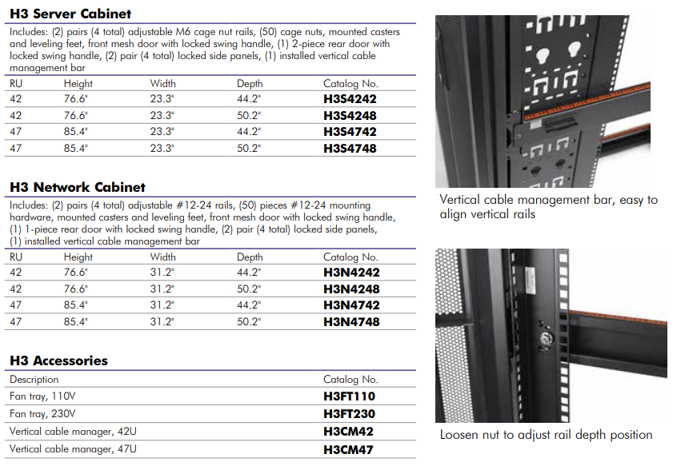

**Appendix G**

**Cabling Parts List**

The following materials are to be used unless a timely submitted substitute is approved by UT OIT.

**CABLES**

* CAT6 Cable
  + Hubbell or
  + Hitachi or
  + General or
  + Panduit or
  + CommScope
* Fiber Optic OSP Cable
  + Fiber shall be single mode manufactured by Corning
* Fiber Optic Riser Cable
  + Fiber shall be single mode manufactured by Corning
* Fiber Optic Horizontal Cable
  + Fiber shall be single mode manufactured by Corning
* Coax Horizontal
  + to be determined on a per project basis.
* Coax
  + to be determined on a per project basis.
* OSP Coax, Flooded
  + to be determined on a per project basis.
* OSP Phone CAT3 Buried Service Wire(BSW)
  + Essex Cable PE89 and /or PE22 as determined by UTK OIT or
  + General Cable PE89 and /or PE22 as determined by UTK OIT
* Riser Phone CAT3 - Copper riser shall be ARMM manufactured by:
  + General or
  + Superior/Essex
* Inner Duct
  + MaxCell 3X3, (Locatable for OSP), color ID

**Appendix H**

**Connectors Parts List**

The following materials are to be used unless a timely submitted substitute is approved by UT OIT.

**CONNECTORS**

* CAT6 Jacks
  + Hubbell HJU6Y or
  + Panduit CJ688TGYL
* Coax RG6 F-Fittings
  + Thomas and Betts SNS1P6U or
  + Thomas and Betts plenum SNS6PLA or
  + Ideal 92-660
* Coax RG11 Fitting
  + Thomas and Betts SNS11AS
* Coax F-81 Jack - (office only, not student rooms)
  + Hubbell SFFEX or
  + Panduit CMFEI
* Fiber Optic Fusion and Field Termination Connectors
  + Corning Glass Fusion Splicing Pigtail
    - Single – Corning 000201R4Z31003M
    - Bundled – Corning 000412R8120003M
  + Corning Unicam LC connectors-when preapproved by OIT
    - Corning 95-200-99

**Appendix I**

**Cross Connect Parts List**

The following materials are to be used unless a timely submitted substitute is approved by UT OIT.

**CROSS CONNECTS**

* CAT6 Patch Panel
  + Hubbell unloaded Patch Panel HPJ48 with HJU6Y jacks or
  + Panduit CP48WSBLY with CJ688TGYL jacks or
* 110 Blocks Rack Mount
  + 100 pair with wire management Hubbell 110rm15 or
  + Panduit P110B100R4YJY with P110C5 connecting blocks
* 66 Blocks Wall Mount (50 pair Cat.5e with cover)
  + Hubbell HPW66M150C5 or
  + Siemon M1-50
* Fiber Optic Connector Housing
  + Corning CCH series or
  + Hubbell FCR series or
  + Panduit FCE series
* Fiber Optic Wall Mount
  + Corning WCH series or
  + Hubbell FCW series or
  + Panduit FWM series
* UTP Protectors (CAT3)
  + Circa 1890 BC1 series

**Appendix J**

**Cable Management Parts List**

The following materials are to be used unless a timely submitted substitute is approved by UT OIT.

**CABLE MANAGEMENT**

* Network Rack with VME 6” Vertical Cable Manager (Black)
  + Hubbell HPW84RR19 plus 2 - VME614C2
  + Panduit R2P 2 Post rack plus 2- WMPVHC45E
* Wall to Rack Mounting Kit
  + Hubbell HLWRK
* Horizontal Management Rack Mount
  + Hubbell HM24C
  + PANDUIT CMPHF2 and cover CMPH2C.
* Cable Management Rings
  + Hubbell MCCPSR4
  + PANDUIT CMPH1
* Cable Management Troughs Wall Mount (110 blocks)
  + Hubbell 110TR series or
  + Panduit P110JTW-X
* Ladder Tray (for ER/TR)
  + Hubbell Next Frame, 18”, “HL” Series or
  + Hoffman LSS18BLK series
* Basket Tray (for corridors)
  + Hubbell, 18”, “HBT” Series or
  + WBT 18”, WBT2X18 Series
* J-Hooks, (up to 40 cables),
  + Caddy Cat32HP or
  + Panduit JP2W-L20
* J-Hooks, (up to 10 cables),
  + Caddy Cat12 or
  + Panduit JP75W-L20
* Equipment Shelf
  + Hubbell MCCCS series or
  + Panduit SRM
* Work Area Outlet (WAO)
  + Coordinate faceplate color with electrical faceplates
    - Hubbell IFP14W (WHITE) or
    - Panduit CBEIWY (uses CHF2IW-X mini-com inserts) or
    - Panduit CFPL4WHY MINICOM Faceplate
* Office/Classroom Faceplate (4 port)
  + Hubbell IFP14W (WHITE) or
  + Panduit CBEIWY (uses CHF2IW-X mini-com inserts) or
  + Panduit CFPL4WHY MINICOM Faceplate
* Office/Classroom Faceplate (6 port)
  + Hubbell IFP16W or
  + Panduit CFPL6WHY
* Office/Classroom Faceplate (9 port)
  + Hubbell IFP212W or
  + Panduit CFPF12WH-2G
* Student Room Faceplate (2 port)
  + Hubbell IFP12W or
  + Panduit CFPL2WHY
* HON Furniture Faceplate (2 port)
  + Hubbell FP2BK (black)
  + Hubbell FP2GY (gray)
  + Panduit CFFPA2BL (black)
  + Panduit CFFPA2IG (gray)
* Blank Faceplate inserts (White)
  + Hubbell SFB series or
  + Panduit CMBWH-X
* Blank Faceplate inserts (Black)
  + Hubbell SFB series or
  + Panduit CMBBL-X
* Blank Faceplate inserts (Gray)
  + Hubbell SFB series or
  + Panduit CMBIG-X

**Appendix K**

**Miscellaneous Material and Parts List**

The following materials are to be used unless a timely submitted substitute is approved by UT OIT.

**Miscellaneous**

* Firestop
  + STI SSP100 Firestopping putty
  + For wall pass through, STI EZ-Path product shall be used.
  + Hilti “Moldable Pliable Putty” CP-618.
    - Tube putty and caulk that cures to an elastomeric solid is not approved in conduit.
  + Hilti FS-ONE around the conduit.
* Fire Retardant Paint
  + Benjamin Moore M59-220(white)
    - up to 2 oz. of tint allowed per gallon.
* Telecommunications Grounding Busbar
  + Hubbell HBBBHR19KT (Rack Mount)
  + Panduit RGRB19Y (Threaded)
  + Panduit RGRB19CN (CAGE NUT RAILS)
  + Hubbell HBBB14210A (TGB)
  + Panduit GB2B0304TPI-1
  + Hubbell HBBB14416G (MTGB)
  + Panduit GB4B0612TPI-1
* Telecommunications Grounding Static Discharge Strap and ESD port
  + HGBESDBM
  + HGBESKDT10
* Power strip (for network rack)
  + Hubbell PH15A10
  + Panduit CMRPSH15
* Code Blue Emergency Phone
  + with keypad and directory plate.
  + CB1D-PAS, with IA4100 / FP2-K for pedestal or IP5000 VoIP phone
  + Use the CB2E-PAS for wall phones with a IA4100/ FP2-K phone.
* Handhole (HH) Pull Box
  + as manufactured by Quazite
  + to be determined on a per project basis.
* Splice Box Quazite
  + Lids are to be identified with “Communications” and have pull slots center pins.
* Splice Enclosures
  + 3M 505 series (for Copper)
  + 3M (for Fiber Optics)
* Duct Seal
  + Polywater APT-16
* Hybrid POE Fiber Components
  + CommScope Hybrid Fiber Cable - PFC-S04012F
  + CommScope POE Extender – PFU-P-C-O-060-02
  + Solara FlatPack S Rectifier – 241122.105
  + Solara FlatPack S Power Supply – CTOS0301.001
* Floor Box Assembly – In slab concrete
  + Hubbell System One Recessed Part No. HBLETSUFBKIT1
  + 1-CFB4G30RCR – 4 gang recess round cover corrosion-resistant on grade box
  + 1-CFBS1R8CVRBLK – round black cover for flush floor
  + 1-PWFBMPCR20GRY – 1 duplex power plate
  + 3-FBMP6DJ – 6 port labeling subplate
* Floor Poke Through Assembly
  + Hubbell System One Recessed Part No. HBLETSUPTKIT1
  + 1-S1R6PTFIT 6” Poke thru
  + 1-S1R6SPW 2 deco opening sub plate
  + 1-S1R6SPZ Duplex power plate
  + 2-NS616W
  + 1-S1R6CVRBLK 6” black cover

Please note: All crosses are functional equivalents and may not be exact.\*\*\*

\*\*\* All crosses are based upon description and may not be exact\*\*\*

**Appendix L**

**OIT Standard Requirements Variance Form**

Complete this form and submit to the UTK Facilities Services Project Manager and approved by the OIT Communications Director. A copy must also be sent to the OIT Communications Assistant Director, OIT Network Manager, Telephone Services Manager and the OIT Project Coordinator. UTK OIT Communications Director will review the request and either accept, modify or deny the variance and will notify the requestor.

Project Name: \_\_\_\_\_\_\_\_\_\_\_\_\_\_\_\_\_\_\_\_\_\_\_\_\_\_\_\_\_\_ Date: \_\_\_\_\_\_\_\_\_\_\_\_\_\_\_\_\_\_\_\_\_\_\_\_\_\_\_\_\_\_\_\_\_\_

Requester: \_\_\_\_\_\_\_\_\_\_\_\_\_\_\_\_\_\_\_\_\_\_\_\_\_\_\_\_\_\_\_\_\_ Title: \_\_\_\_\_\_\_\_\_\_\_\_\_\_\_\_\_\_\_\_\_\_\_\_\_\_\_\_\_\_\_\_\_\_\_

Company: \_\_\_\_\_\_\_\_\_\_\_\_\_\_\_\_\_\_\_\_\_\_\_\_\_\_\_\_\_\_\_\_\_\_ General Contractor: \_\_\_\_\_\_\_\_\_\_\_\_\_\_\_\_\_\_\_\_\_\_\_

FS Project Mgr: \_\_\_\_\_\_\_\_\_\_\_\_\_\_\_\_\_\_\_\_\_\_\_\_\_\_\_\_\_\_ OIT Project Mgr: \_\_\_\_\_\_\_\_\_\_\_\_\_\_\_\_\_\_\_\_\_\_\_\_\_

Reason for Variance:\_\_\_\_\_\_\_\_\_\_\_\_\_\_\_\_\_\_\_\_\_\_\_\_\_\_\_\_\_\_\_\_\_\_\_\_\_\_\_\_\_\_\_\_\_\_\_\_\_\_\_\_\_\_\_\_\_\_\_\_\_\_\_\_\_\_\_\_\_\_\_\_\_\_\_\_\_

\_\_\_\_\_\_\_\_\_\_\_\_\_\_\_\_\_\_\_\_\_\_\_\_\_\_\_\_\_\_\_\_\_\_\_\_\_\_\_\_\_\_\_\_\_\_\_\_\_\_\_\_\_\_\_\_\_\_\_\_\_\_\_\_\_\_\_\_\_\_\_\_\_\_\_\_\_\_\_\_\_\_\_\_\_\_\_\_\_\_\_\_\_

\_\_\_\_\_\_\_\_\_\_\_\_\_\_\_\_\_\_\_\_\_\_\_\_\_\_\_\_\_\_\_\_\_\_\_\_\_\_\_\_\_\_\_\_\_\_\_\_\_\_\_\_\_\_\_\_\_\_\_\_\_\_\_\_\_\_\_\_\_\_\_\_\_\_\_\_\_\_\_\_\_\_\_\_\_\_\_\_\_\_\_\_\_

­­­­­­­­­­­­­­­­­­­\_\_\_\_\_\_\_\_\_\_\_\_\_\_\_\_\_\_\_\_\_\_\_\_\_\_\_\_\_\_\_\_\_\_\_\_\_\_\_\_\_\_\_\_\_\_\_\_\_\_\_\_\_\_\_\_\_\_\_\_\_\_\_\_\_\_\_\_\_\_\_\_\_\_\_\_\_\_\_\_\_\_\_\_\_\_\_\_\_\_\_\_\_

\_\_\_\_\_\_\_\_\_\_\_\_\_\_\_\_\_\_\_\_\_\_\_\_\_\_\_\_\_\_\_\_\_\_\_\_\_\_\_\_\_\_\_\_\_\_\_\_\_\_\_\_\_\_\_\_\_\_\_\_\_\_\_\_\_\_\_\_\_\_\_\_\_\_\_\_\_\_\_\_\_\_\_\_\_\_\_\_\_\_\_\_\_

The variance requested is due to (check all that applies):

Cost \_\_\_\_\_ Amount $\_\_\_\_\_\_\_ Schedule Impact \_\_\_\_\_ Days impacted \_\_\_\_\_\_\_

Suggested Remedy(s):\_\_\_\_\_\_\_\_\_\_\_\_\_\_\_\_\_\_\_\_\_\_\_\_\_\_\_\_\_\_\_\_\_\_\_\_\_\_\_\_\_\_\_\_\_\_\_\_\_\_\_\_\_\_\_\_\_\_\_\_\_\_\_\_\_\_\_\_\_\_\_\_\_\_\_

\_\_\_\_\_\_\_\_\_\_\_\_\_\_\_\_\_\_\_\_\_\_\_\_\_\_\_\_\_\_\_\_\_\_\_\_\_\_\_\_\_\_\_\_\_\_\_\_\_\_\_\_\_\_\_\_\_\_\_\_\_\_\_\_\_\_\_\_\_\_\_\_\_\_\_\_\_\_\_\_\_\_\_\_\_\_\_\_\_\_\_\_\_

\_\_\_\_\_\_\_\_\_\_\_\_\_\_\_\_\_\_\_\_\_\_\_\_\_\_\_\_\_\_\_\_\_\_\_\_\_\_\_\_\_\_\_\_\_\_\_\_\_\_\_\_\_\_\_\_\_\_\_\_\_\_\_\_\_\_\_\_\_\_\_\_\_\_\_\_\_\_\_\_\_\_\_\_\_\_\_\_\_\_\_\_\_

\_\_\_\_\_\_\_\_\_\_\_\_\_\_\_\_\_\_\_\_\_\_\_\_\_\_\_\_\_\_\_\_\_\_\_\_\_\_\_\_\_\_\_\_\_\_\_\_\_\_\_\_\_\_\_\_\_\_\_\_\_\_\_\_\_\_\_\_\_\_\_\_\_\_\_\_\_\_\_\_\_\_\_\_\_\_\_\_\_\_\_\_\_

…...............................................................……………………………………………………………………………………………………….………….

**To be completed by UTK OIT**

Comments and or Reason for decision: \_\_\_\_\_\_\_\_\_\_\_\_\_\_\_\_\_\_\_\_\_\_\_\_\_\_\_\_\_\_\_\_\_\_\_\_\_\_\_\_\_\_\_\_\_\_\_\_\_\_\_\_\_\_\_\_\_\_\_\_\_

\_\_\_\_\_\_\_\_\_\_\_\_\_\_\_\_\_\_\_\_\_\_\_\_\_\_\_\_\_\_\_\_\_\_\_\_\_\_\_\_\_\_\_\_\_\_\_\_\_\_\_\_\_\_\_\_\_\_\_\_\_\_\_\_\_\_\_\_\_\_\_\_\_\_\_\_\_\_\_\_\_\_\_\_\_\_\_\_\_\_\_\_\_

\_\_\_\_\_\_\_\_\_\_\_\_\_\_\_\_\_\_\_\_\_\_\_\_\_\_\_\_\_\_\_\_\_\_\_\_\_\_\_\_\_\_\_\_\_\_\_\_\_\_\_\_\_\_\_\_\_\_\_\_\_\_\_\_\_\_\_\_\_\_\_\_\_\_\_\_\_\_\_\_\_\_\_\_\_\_\_\_\_\_\_\_\_

\_\_\_\_\_\_\_\_\_\_\_\_\_\_\_\_\_\_\_\_\_\_\_\_\_\_\_\_\_\_\_\_\_\_\_\_\_\_\_\_\_\_\_\_\_\_\_\_\_\_\_\_\_\_\_\_\_\_\_\_\_\_\_\_\_\_\_\_\_\_\_\_\_\_\_\_\_\_\_\_\_\_\_\_\_\_\_\_\_\_\_\_\_

\_\_\_\_\_\_\_\_\_\_\_\_\_\_\_\_\_\_\_\_\_\_\_\_\_\_\_\_\_\_\_\_\_\_\_\_\_\_\_\_\_\_\_\_\_\_\_\_\_\_\_\_\_\_\_\_\_\_\_\_\_\_\_\_\_\_\_\_\_\_\_\_\_\_\_\_\_\_\_\_\_\_\_\_\_\_\_\_\_\_\_\_\_

This request has been (circle): Approved / Modified / Denied

OIT Director Signature \_\_\_\_\_\_\_\_\_\_\_\_\_\_\_\_\_\_\_\_\_\_\_\_\_\_\_\_\_ Date: \_\_\_\_\_\_\_\_\_\_\_\_\_\_\_\_\_\_\_

**Appendix M**

**Sample Labeling**

|  |  |  |
| --- | --- | --- |
| Sample Rack Labeling | cid:IMG_70811.jpg  Sample Patch Panel Labeling | Sample Rear of Patch Panel Labeling |
| Sample Rear of Faceplate Labeling | Sample Faceplate Labeling | Image result for raceway with a hubbell surface mounted box for utp cabling  Each socket must be labeled |
| Sample Fiber Breakout Box Patch Panel Labeling | Sample Rear of Fiber Patch Panel Horizontal Cabling Labeling | Sample Fiber Faceplate Labeling |
| Light Pole with Surveillance Camera and Wireless AP | Sample Light Pole Access Panel Labeling | Sample Light Pole Access Panel and Horizontal Cable Labeling |
| Typical Code Blue Phone on a Pedestal | Sample Blue Phone Pedestal Horizontal Cable Labeling | Sample Fiber Breakout Box Patch Panel Labeling |
| Image result for what is a handhole  Typical Handhole Box | **See UTK OIT**  **for Labeling Tags**  Sample Handhole Cabel Labeling | Sample Fiber Breakout Box Patch Panel Labeling |

**Appendix N**

**OIT Requirements Change Request Form**

A change request form is the part of the change management process, which is a discipline that helps project leaders prepare, equip and support change. This change request template is the first step towards collecting the data that will determine how we deal with change, so that it doesn’t create issues or problems in your group workflow. **Please complete this form and submit to the OIT Project Coordinator to start the approval process. A copy will be sent to the OIT Network Manager and Telephone Services Manager. UTK OIT Communications Director, Network Manager and Telephone Services Manager will review the request and either accept, modify or deny the variance and will notify the requestor**.

|  |  |  |
| --- | --- | --- |
| **Date:** | **Requestor’s Name:** | **Communications Group Name:** |
|  |  |  |
| **Section Name:** | | **Page Number:** |
|  | | |
| **Original Wording:** | | |
|  |  |  |
| **Revised Wording Request:** | | |
|  |  |  |
| **Coordinator Sign Off** | **OIT Director Sign Off** | **Revised Sign Off** |